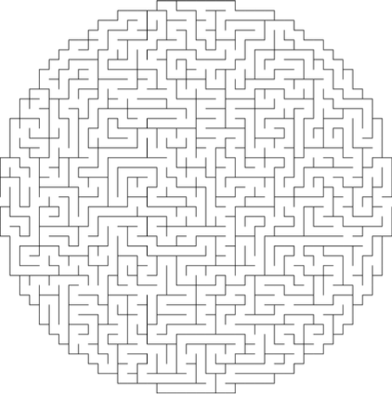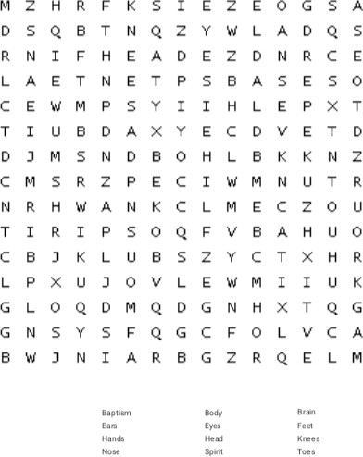

MAZE

**Many Parts, One Body**

1 Corinthians 12:27

Word Search

Copyright © Sermons4Kids, Inc. May be reproduced for Ministry Use

Your Church Name City or Town

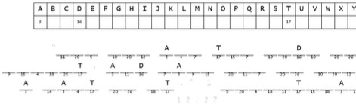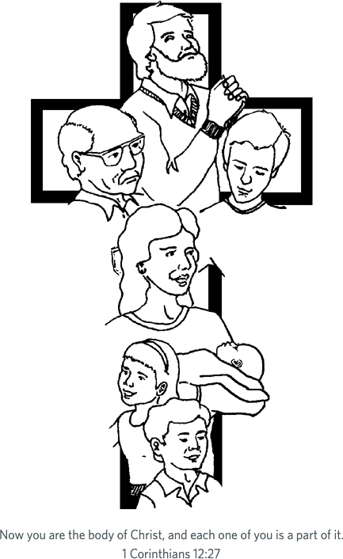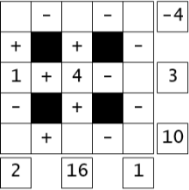

Decoder Puzzle

Each number represents a letter of the alphabet. Substitute correct letter for the numbers to reveal the coded words.

Mystery Math

Fill in the missing numbers. The missing values are the whole numbers between 1 and 9. Each number is only used once.

Each row is a math equation.

Each column is a math equation. Remember that multiplication and division are performed before addition and subtraction.