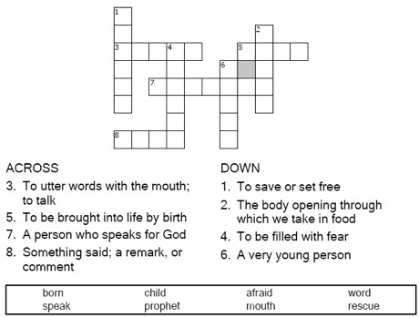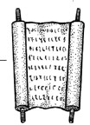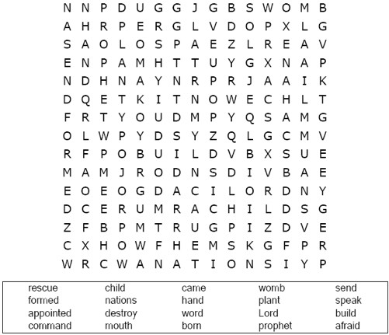

Jeremiah 1:4-10

**Your Church Name Here**

Anytown, USA

Copyright © Sermons4Kids, Inc. May be reproduced for Ministry Use

Children’s Worship Bulletin

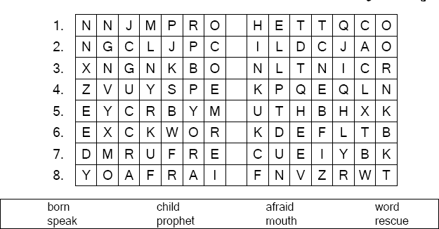

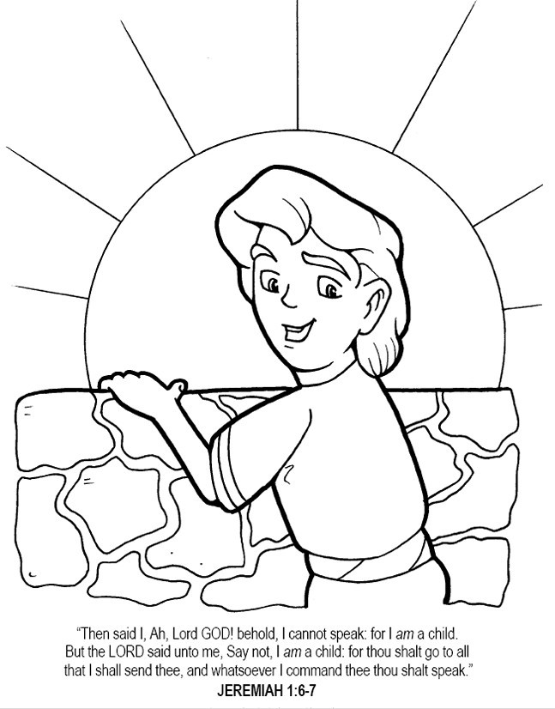

Each line of the puzzle has one word hidden in a list of random letters. The blank space is a missing letter that belongs to that word. Fill in the missing letter

Copyright © Calvary Chapel Used by permission