Maze

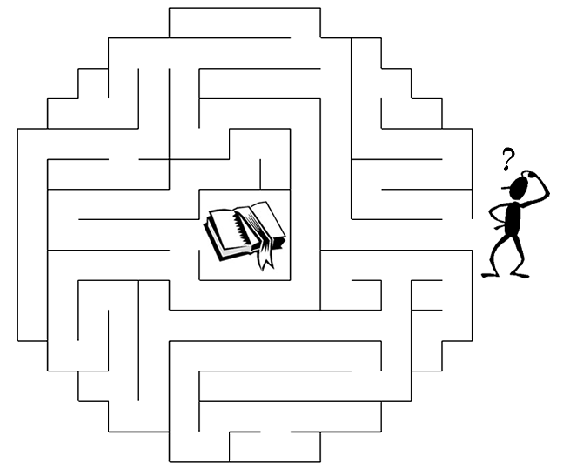
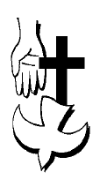
Copyright © Sermons4Kids, Inc.
May be reproduced for Ministry Use

Children’s Worship Bulletin

The Unseen Power

John 16:12-13
Word Search

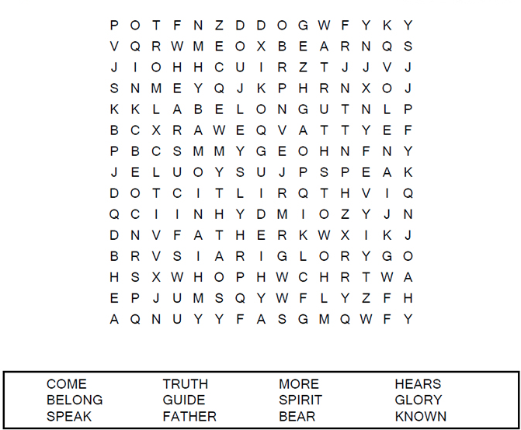
Your Church Name Here
Anytown, USA

Spiral

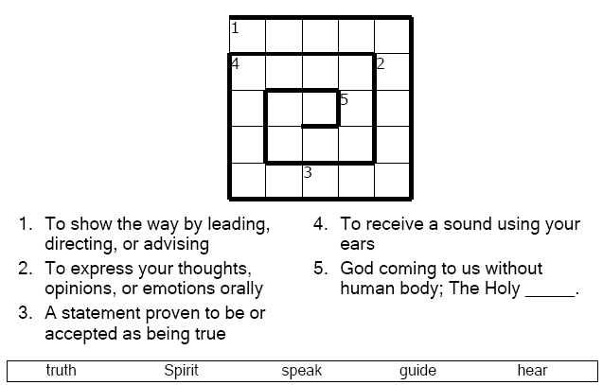

But when he, the Spirit of Truth, comes, he will guide you into all truth. He will not speak on his own; he will speak only what he hears, and he will tell you what is yet to come.
John 16:13 (NIV)

Color Me!
