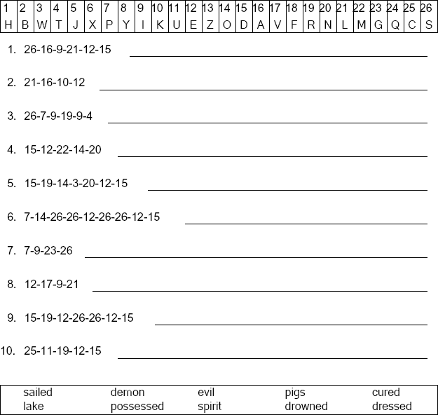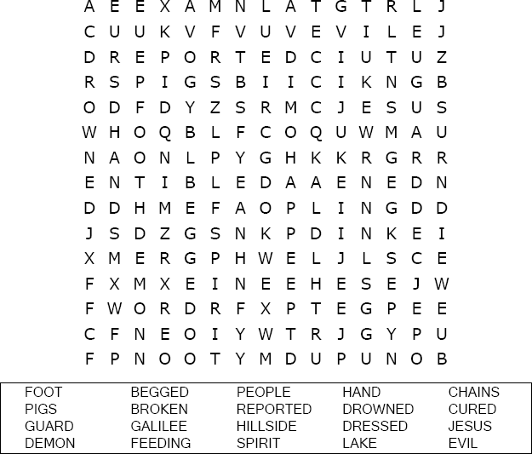

Luke 8:35

Copyright © Sermons4Kids, Inc. May be reproduced for Ministry Use

**Your Church Name Here**

Anytown, USA

Children’s Worship Bulletin

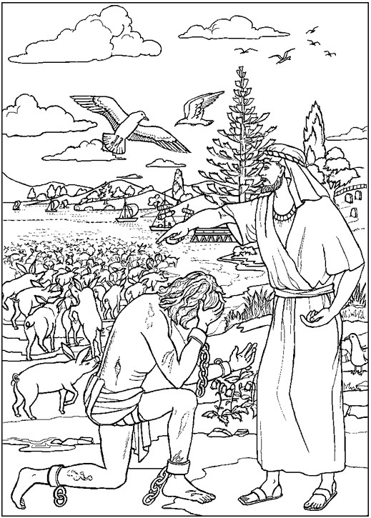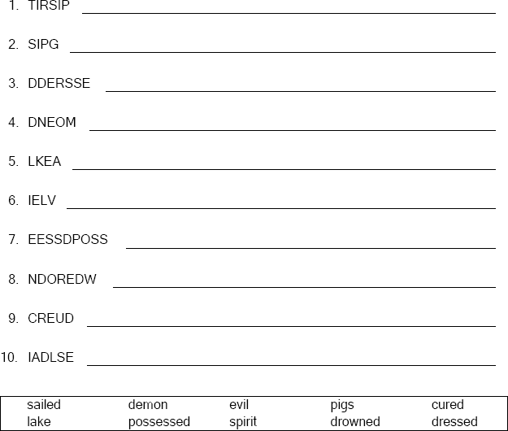



Unscramble the letters and write the word correctly .

Copyright © ABDA Acts - Arts and Publishing Used by permission.