Crossword Puzzle

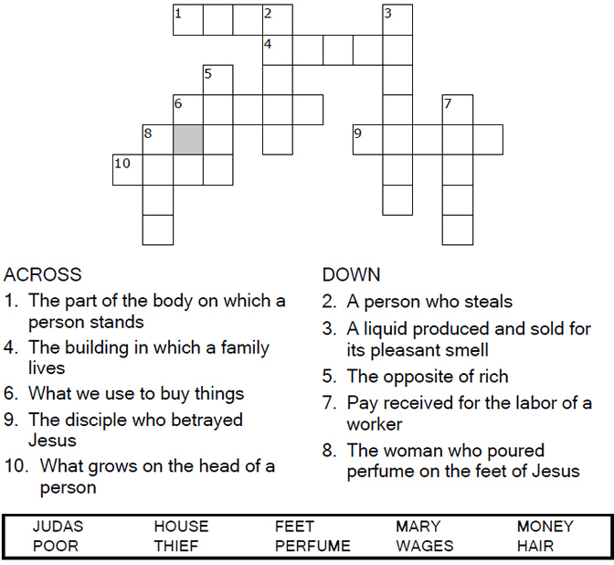

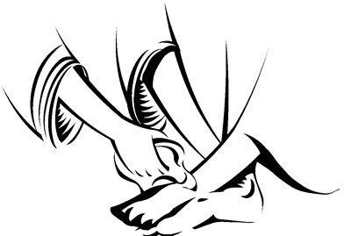

Copyright © Sermons4Kids, Inc.

May be reproduced for Ministry Use

Children’s Worship Bulletin



John 12:1-8

Word Search

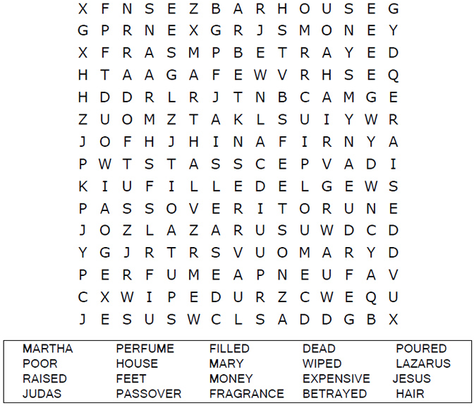

**Your Church Name Here**Anytown, Anywhere

Dot to Dot

Connect the dots to complete the picture.

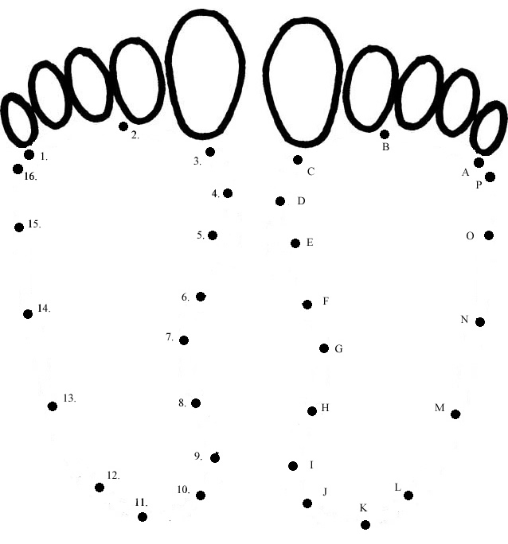

Then Mary took about a pint of pure nard, an  
expensive perfume; she poured it on Jesus'  
feet and wiped his feet with her hair.  
John 12:3a (NIV))

Color Me!

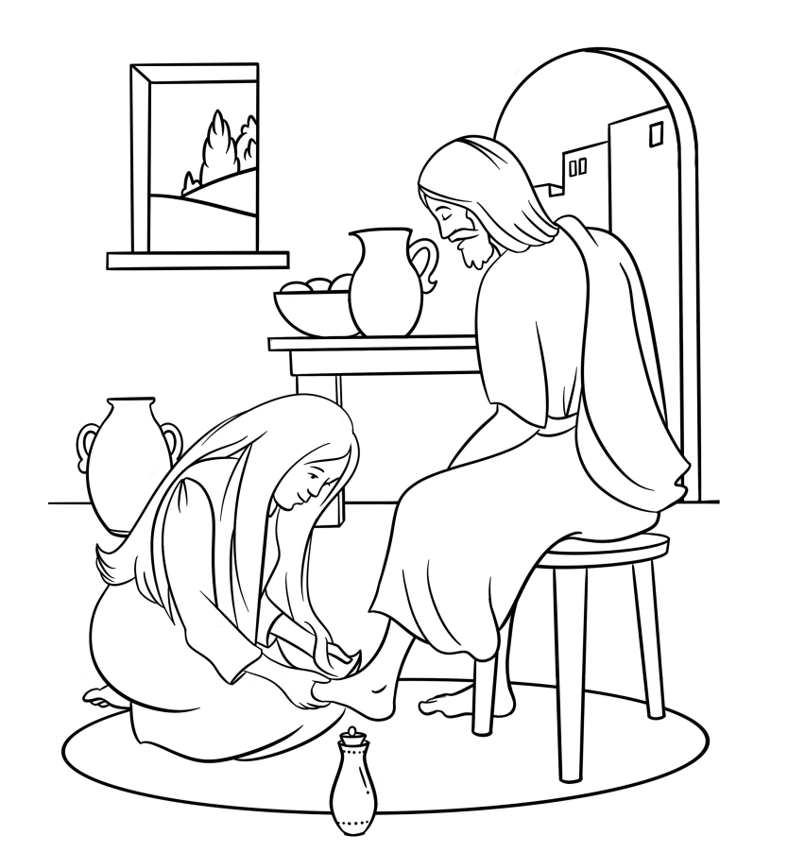

Mary Anoints Jesus’ Feet  
John 12:1-8

Copyright © CalvaryCurriculum.com  
Used by Permission