Crossword Puzzle

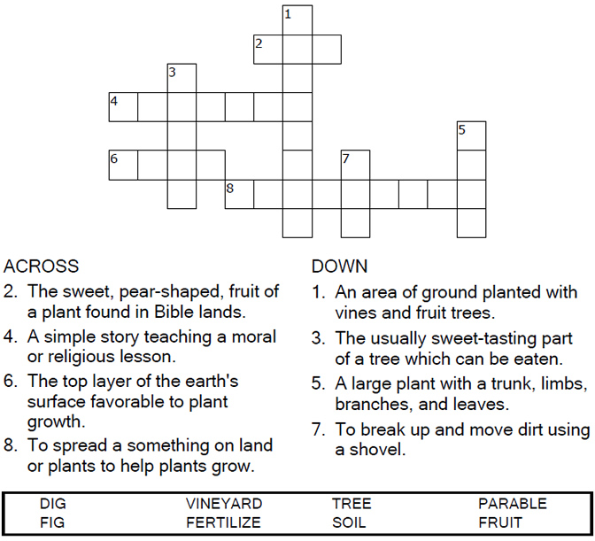



Copyright © Sermons4Kids, Inc.

May be reproduced for Ministry Use

Children’s Worship Bulletin



Luke 13:1-9

Word Search

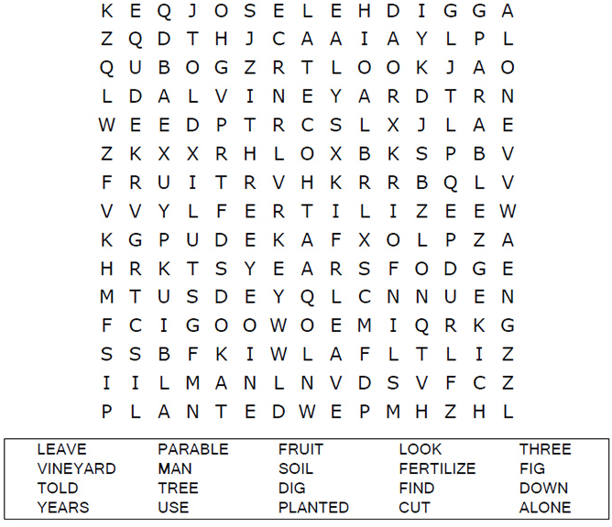

**Your Church Name Here**Anytown, USA

Coloring Page

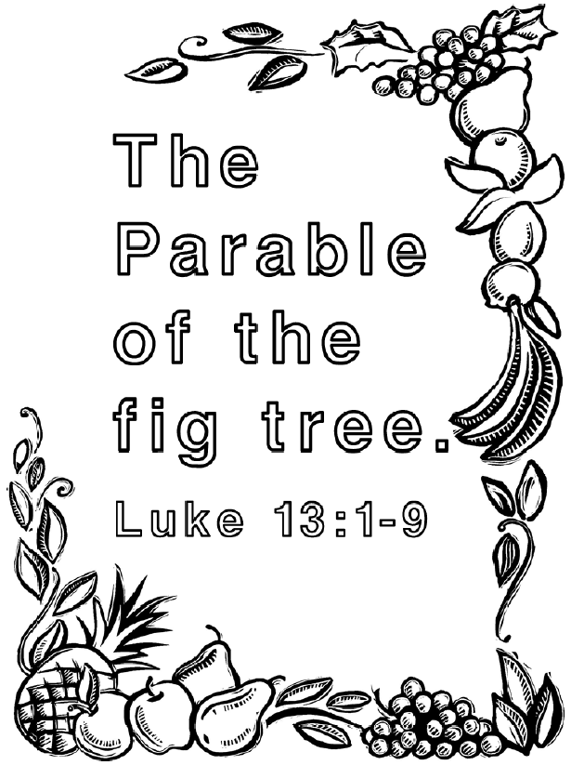

**God wants us to bear good fruit!**

Dot to Dot Puzzle

