Crossword puzzle

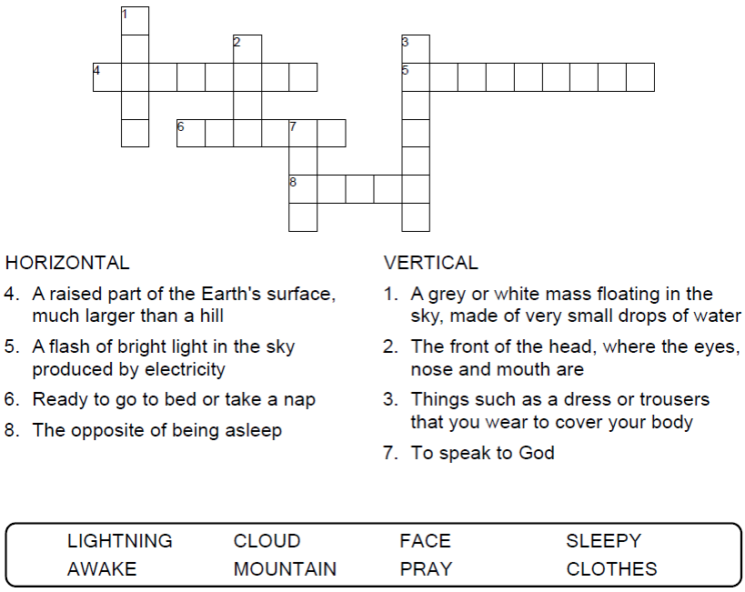



Copyright © Sermons4Kids, Inc.

May be reproduced for Ministry Use

Children’s Worship Bulletin



Luke 9:28-36

Word search

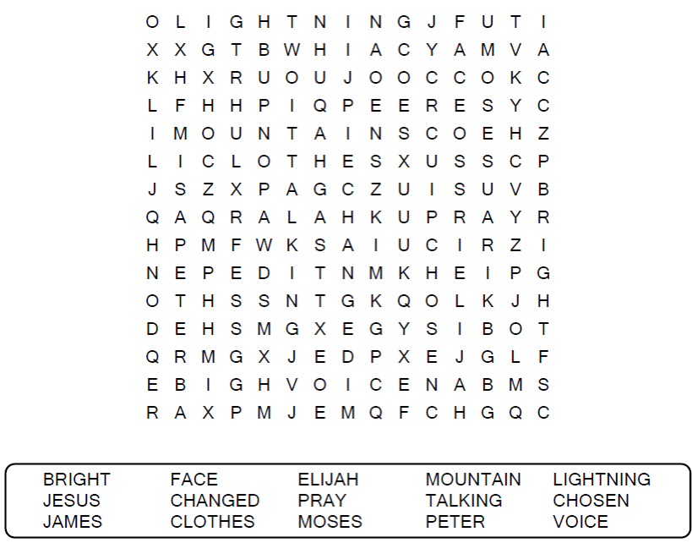

**Your Church Name Here**

Anytown, USA

Color me!

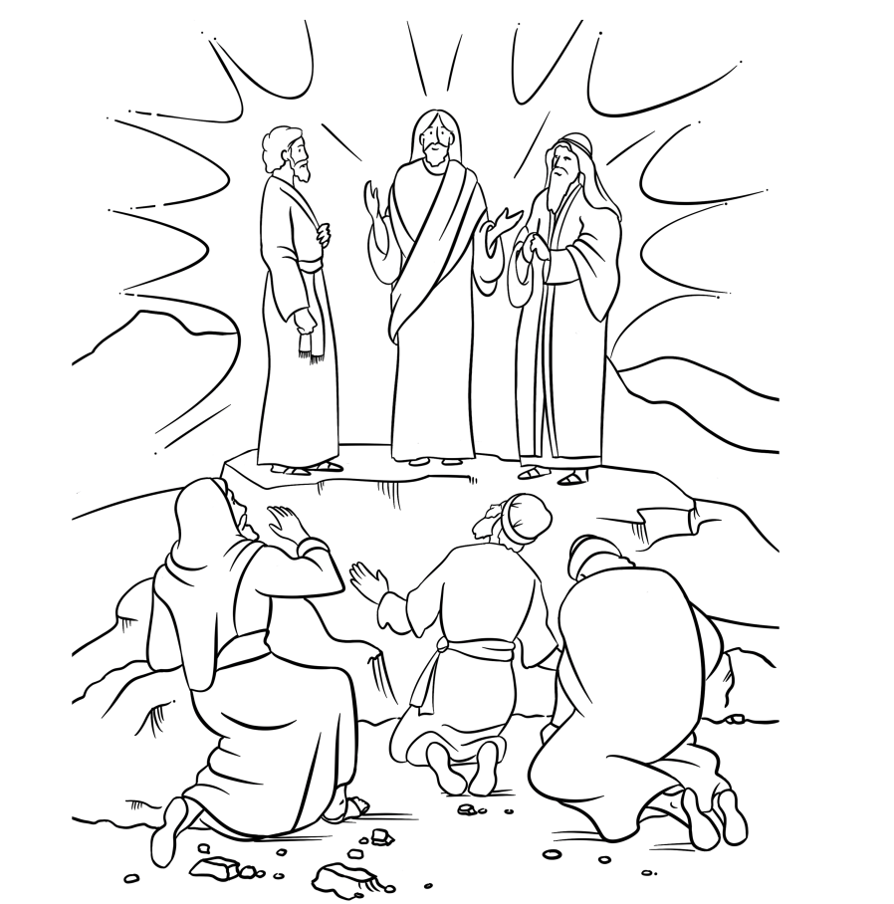

The Transfiguration

Copyright © CalvaryCurriculum.com  
Used by Permission

Maze puzzle

Can you find the way to Jesus, Moses, and Elijah?

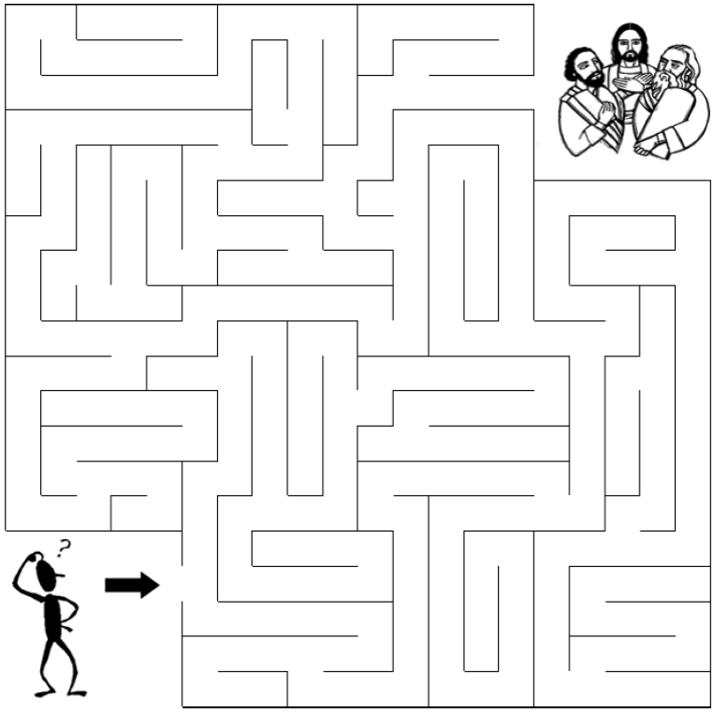

As he was praying, the appearance of his face changed, and his clothes became as bright as a flash of lightning. Two men, Moses and Elijah, appeared in glorious splendor, talking with Jesus. They spoke about his departure, which he was about to bring to fulfillment at Jerusalem.  
Luke 9:34-35 (NIV)