Crossword Puzzle

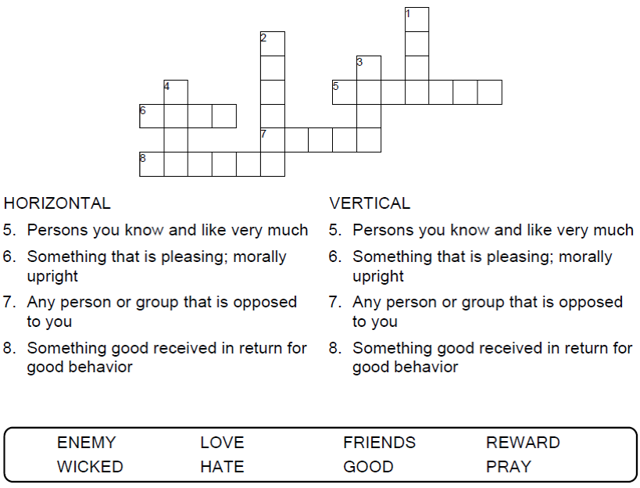



Copyright © Sermons4Kids, Inc.

May be reproduced for Ministry Use

**Children’s Worship Bulletin**



Luke 6:27-38

Word Search Puzzle

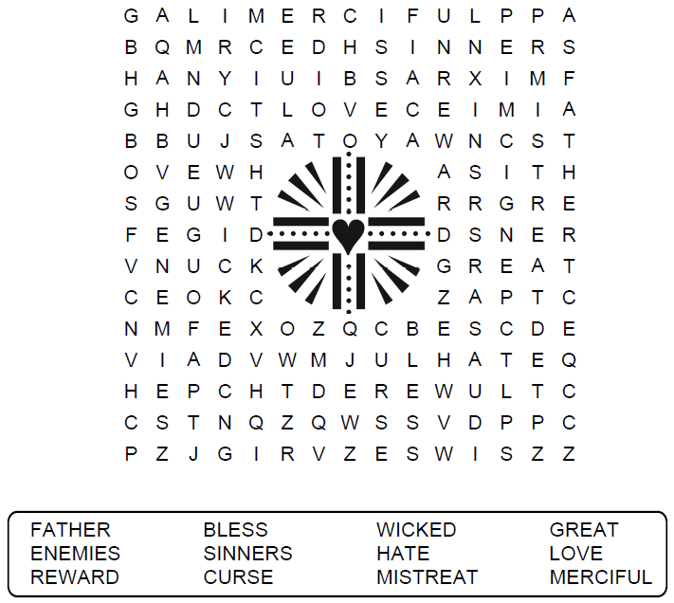

Your Church Name  
City or Town

Coloring Page

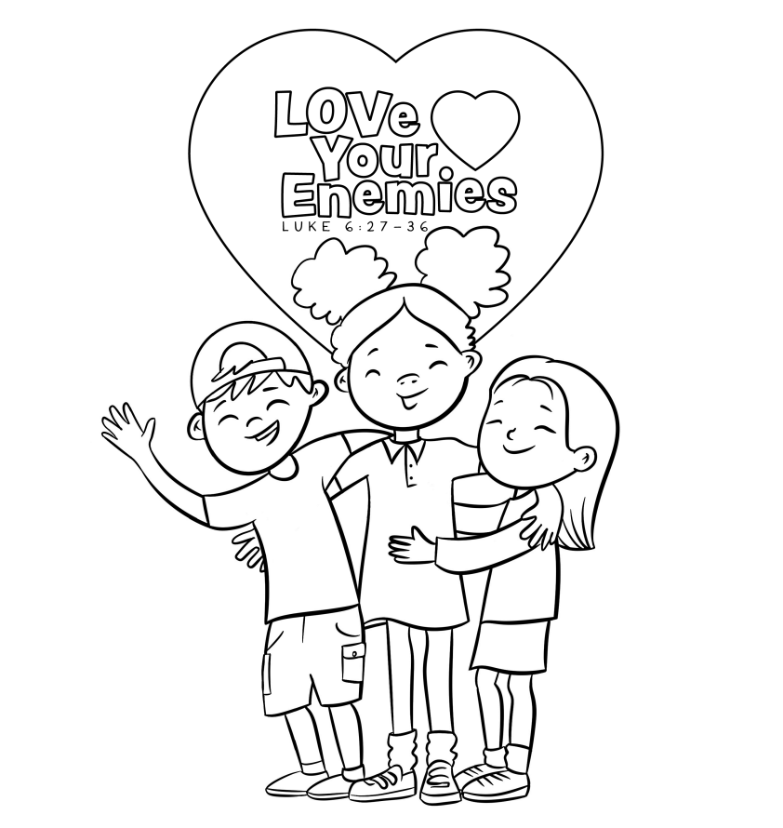  
“Do to others as you would have them do to you.”  
Luke 6:31

Copyright © CalvaryCurriculum.com  
Used by Permission

Decoder Puzzle

Each number represents a letter of the alphabet. Substitute  
the correct letter for the numbers to reveal the coded words.   
  
