Crossword puzzle

Happiness Is. . .

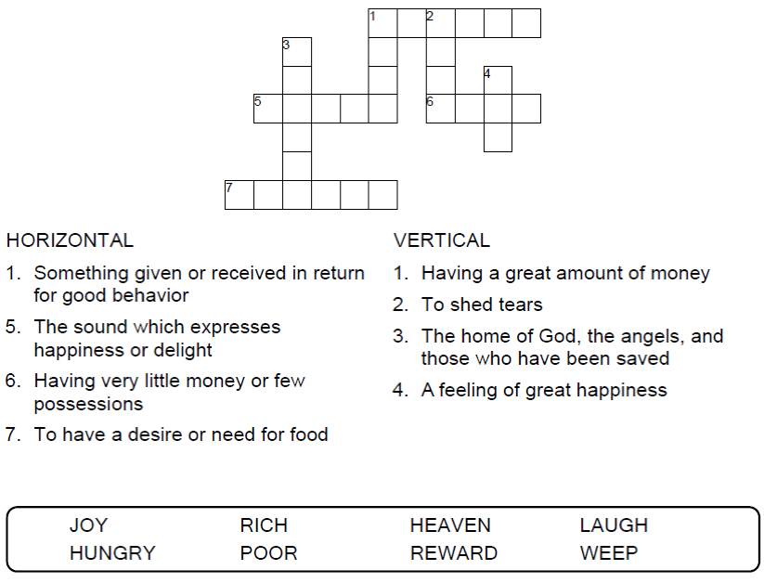

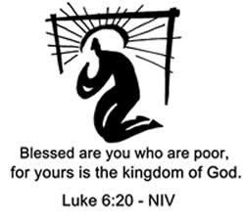

Copyright © Sermons4Kids, Inc.

May be reproduced for Ministry Use

Children’s Worship Bulletin



Luke 6:17-26

Word search puzzle

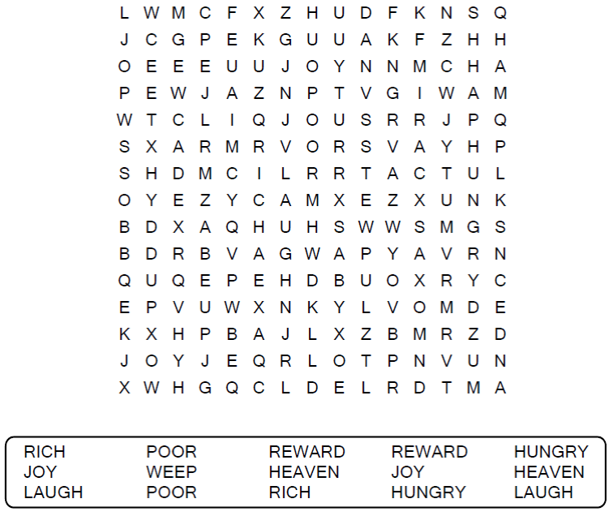

**Your Church Name Here**Anytown, USA

Decoder puzzle

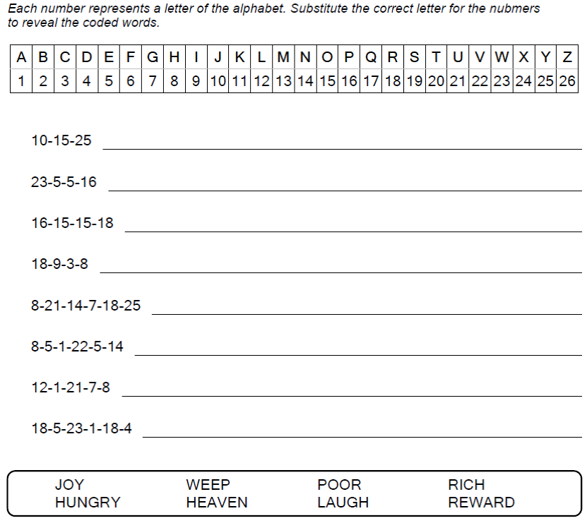

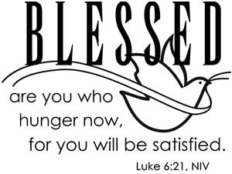

Color me!

