Spiral puzzle

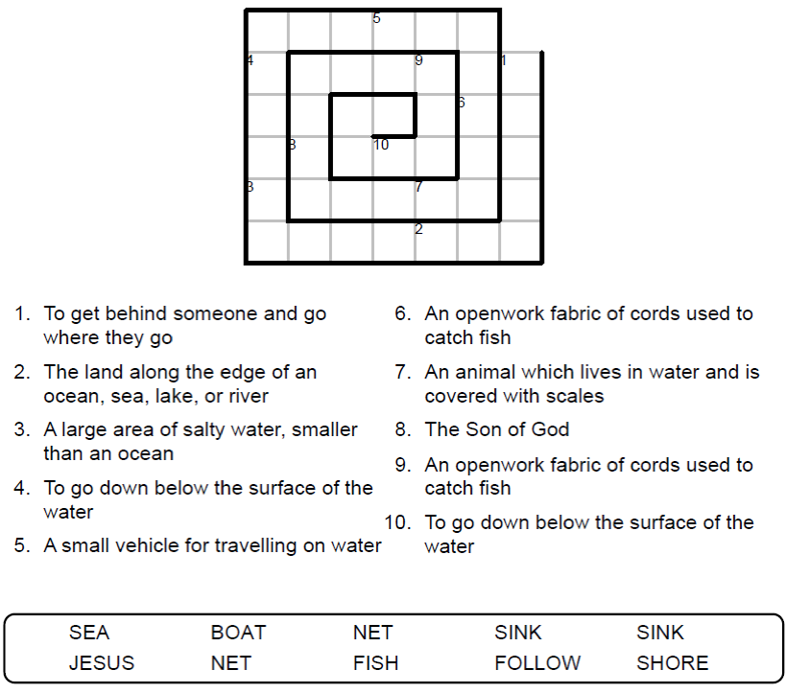

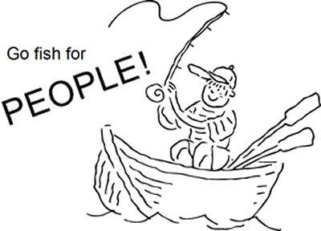

Copyright © Sermons4Kids.com

May be reproduced for Ministry Use

Children’s Worship Bulletin

What a Catch!

Luke 5:1-11

Word search puzzle

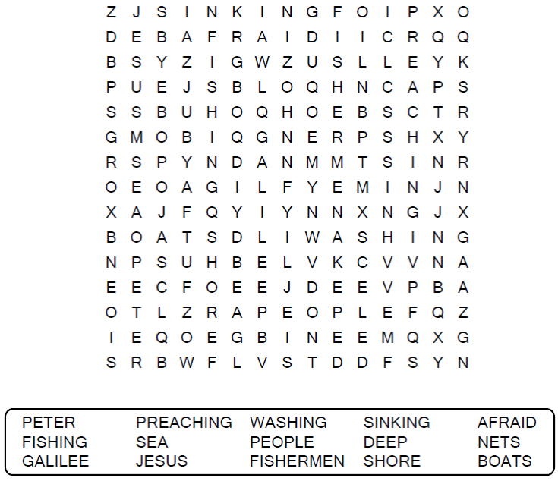

**Your Church Name Here**

Anytown, Anywhere

Color me!

Then Jesus said to Simon, "Don't be afraid; from now on you will catch men." So they pulled their boats up on shore, left everything and followed him.  
Luke 5:10-11

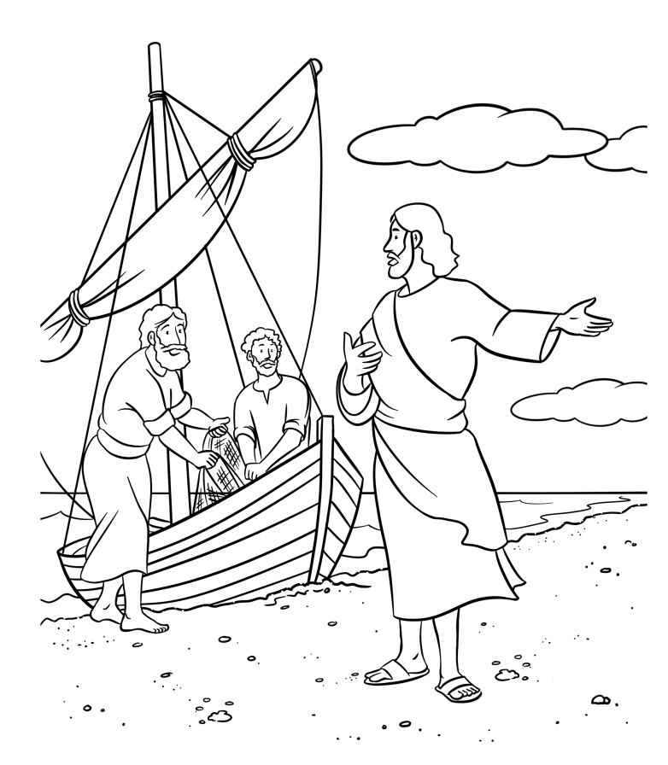

Copyright © CalvaryCurriculum.com  
Used by Permission

Decoder puzzle

