Crossword puzzle

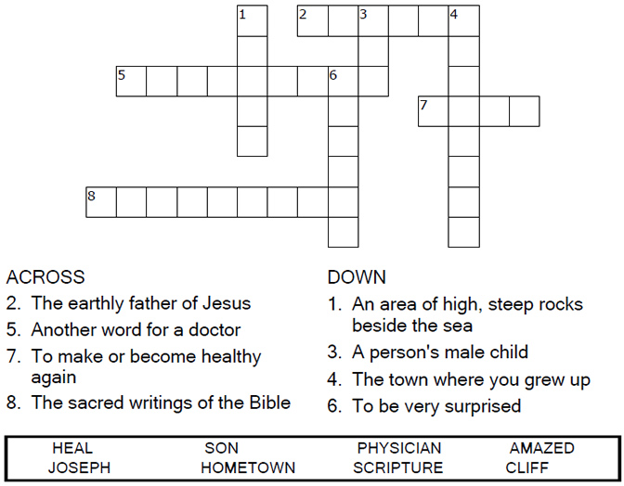

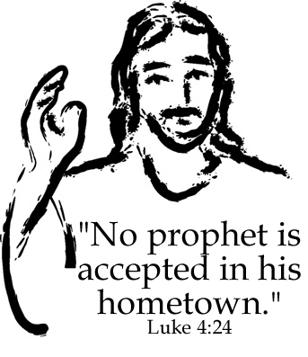

Copyright © Sermons4Kids, Inc.

May be reproduced for Ministry Use

Children’s Worship Bulletin



Luke 4:21-30

Word search puzzle

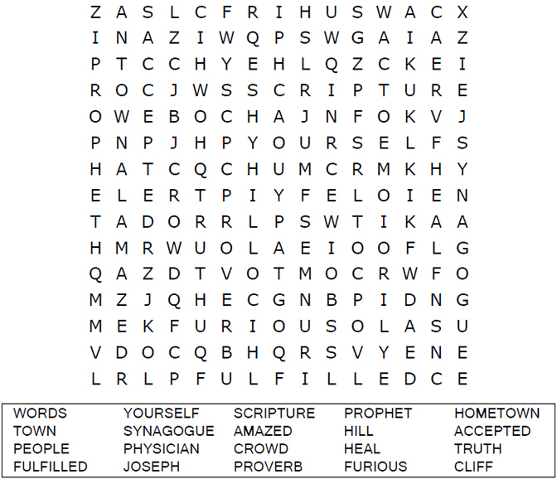

**Your Church Name Here**

Anytown, USA

Coloring page

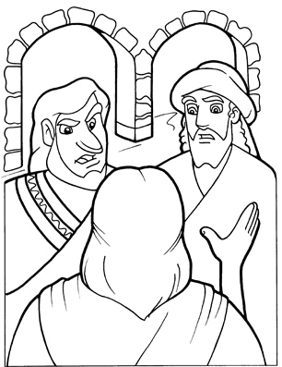

"I tell you the truth," he continued, "no prophet is  
accepted in his hometown.”  
Luke 4:24

Copyright © CalvaryCurriculum.com  
Used by Permission

Dot to dot puzzle

All the people in the synagogue were furious when they heard this. They got up, drove him out of the town, and took him to the brow of the hill on which the town was built, in order to throw him down the cliff. But he walked right through the crowd and went on his way.  
Luke 4:28-30(NIV)

The Synagogue

