Crossword Puzzle

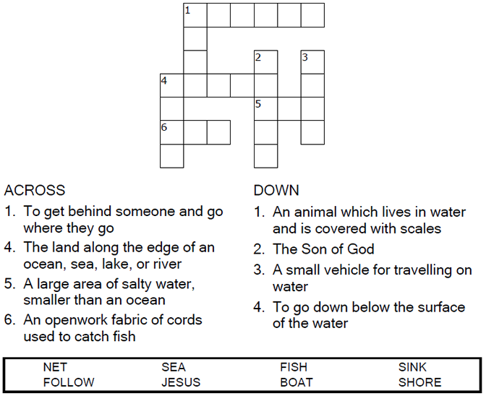

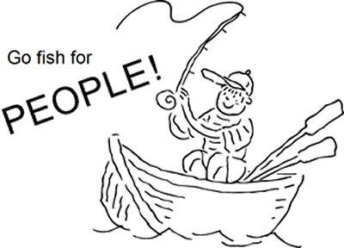

Copyright © Sermons4Kids, Inc.

May be reproduced for Ministry Use

Children’s Worship Bulletin



Luke 5:1-11

Word Search Puzzle

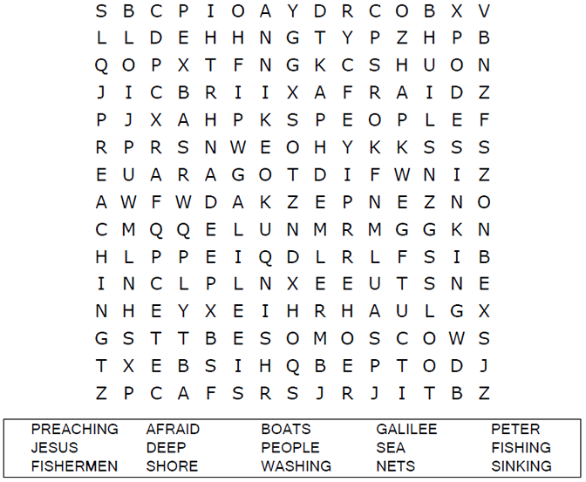

**Your Church Name Here**

Anytown, USA

Color Me!

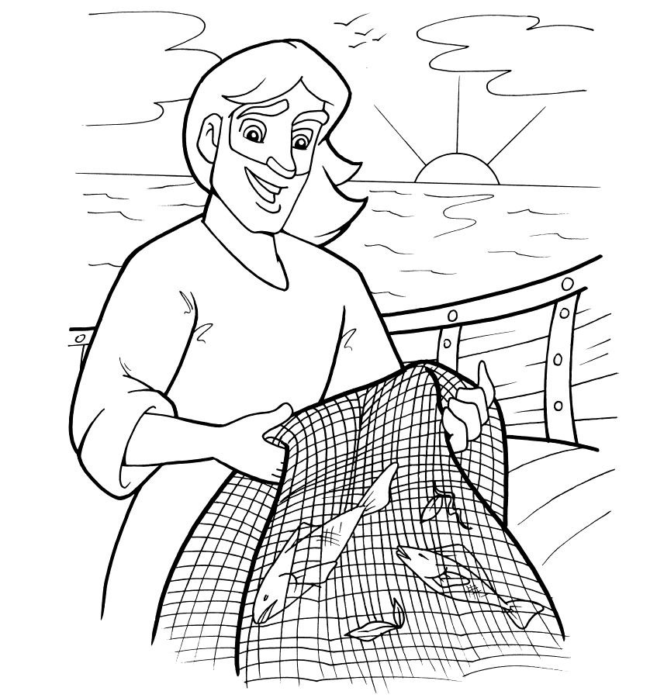

Then Jesus said to Simon, "Don't be afraid; from now on you will catch men." So they pulled their boats up on shore, left everything and followed him.  
Luke 5:10-11

Dot to Dot Puzzle

When he had finished speaking, he said to Simon, "Put out into deep water, and let down the nets for a catch." Simon answered, "Master, we've worked hard all night and haven't caught anything. But because you say so,  
 I will let down the nets."  
Luke 5:4-5 (NIV)

Fishing for People

