Crossword Puzzle

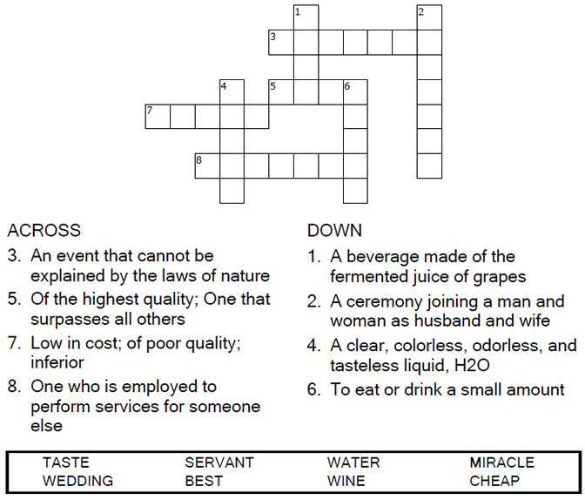

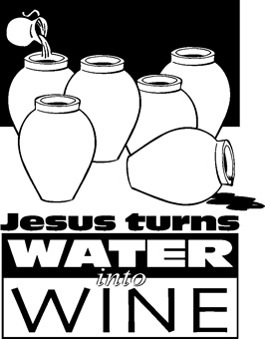

Copyright © Sermons4Kids, Inc.

May be reproduced for Ministry Use

Children’s Worship Bulletin



John 2:1-11

Word Search Puzzle

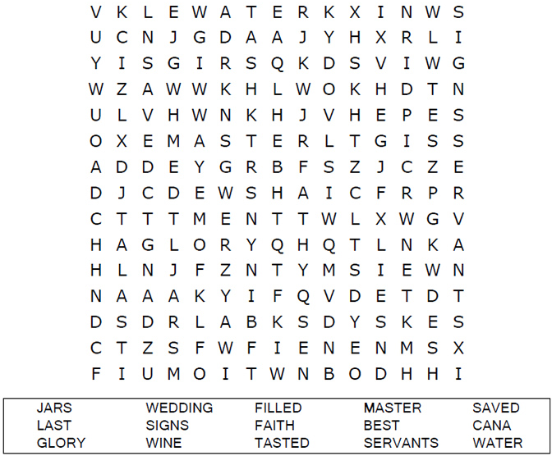

**Your Church Name Here**

Anytown, USA

Decoder Puzzle

Each number represents a letter of the alphabet. Substitute the correct letter for the numbers to reveal the coded words.

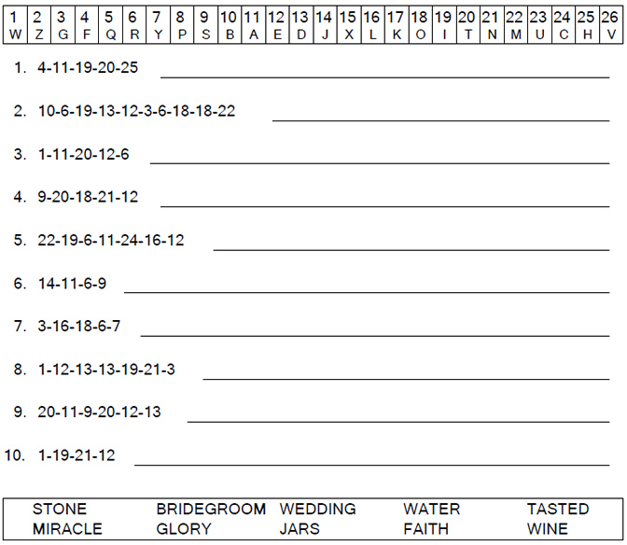

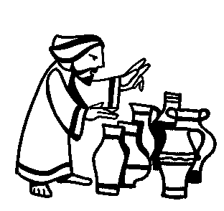

Fill in the Blanks

Complete the sentences by filling in the blanks with the correct words from the word bank below the puzzle. You can check your answers in Luke 3:15-16, 21-22 (NIV)

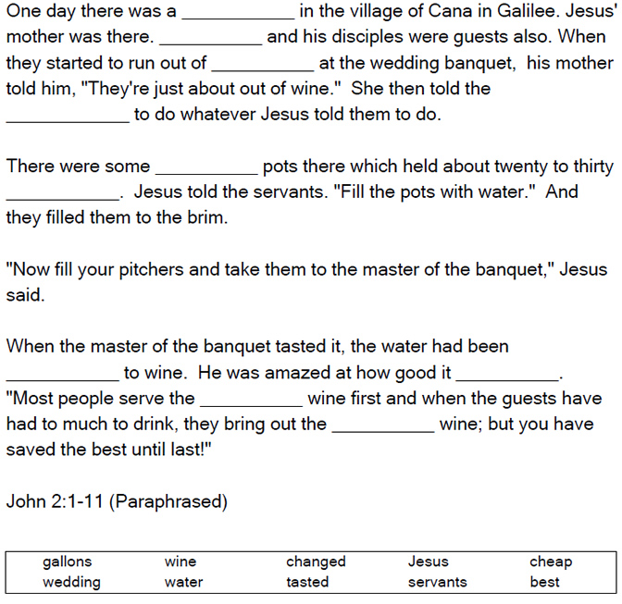

The Miracles of Jesus

