Crossword Puzzle

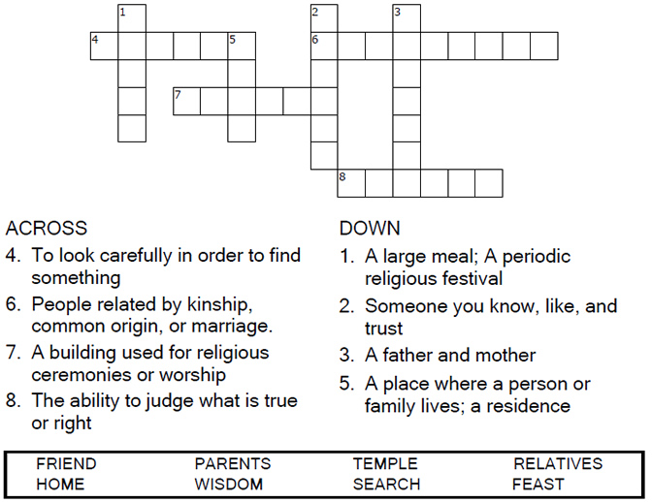



Copyright © Sermons4Kids, Inc.

May be reproduced for Ministry Use

Children’s Worship Bulletin



Luke 2:41-52

Word search puzzle

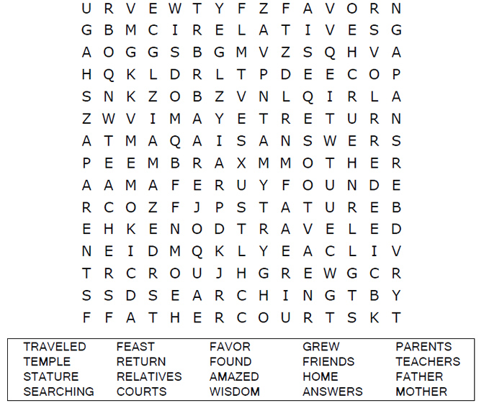

**Your Church Name Here**

Anytown, USA

maze Puzzle

Can you help Mary and Joseph find Jesus in the Temple?

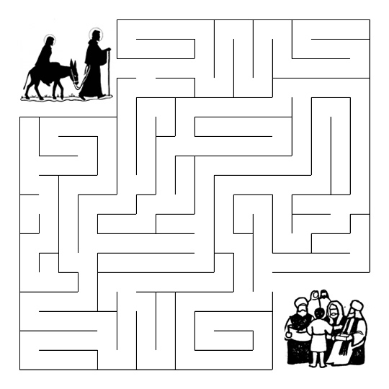



Multiple choice quiz

Select the word that best matches the definition.  
Answers are based on Luke 2:41-49 (NIV).

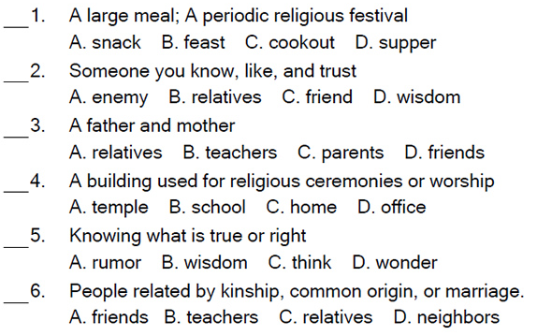

Dot to Dot Puzzle

