Crossword Puzzle

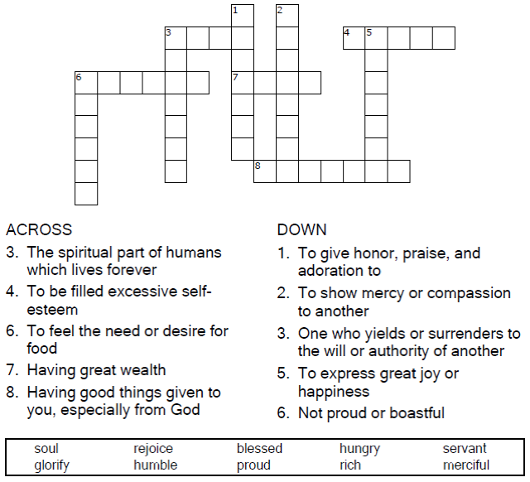

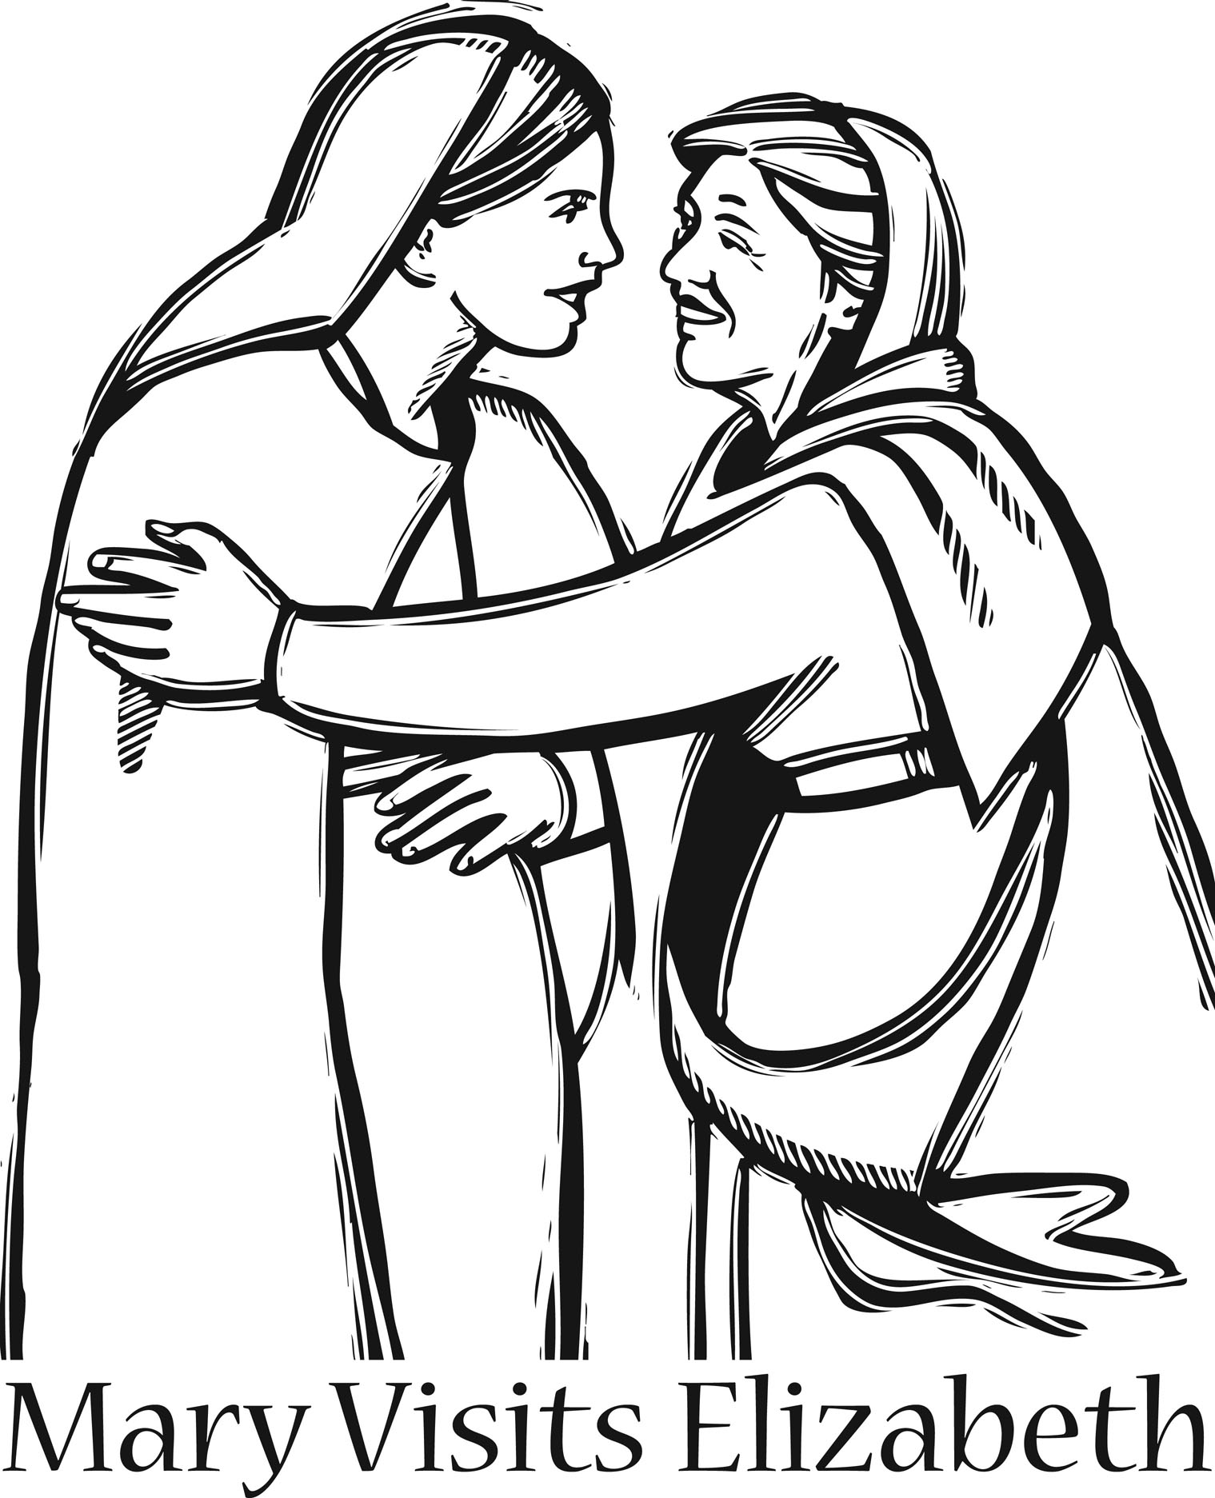

Copyright © Sermons4Kids, Inc.

May be reproduced for Ministry Use

Children’s Worship Bulletin



Luke 1:39-45

Word Search Puzzle

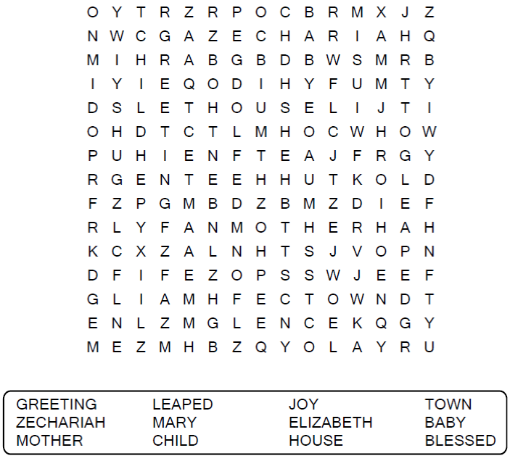

**Your Church Name Here**

Anytown, Anywhere

Coloring Page

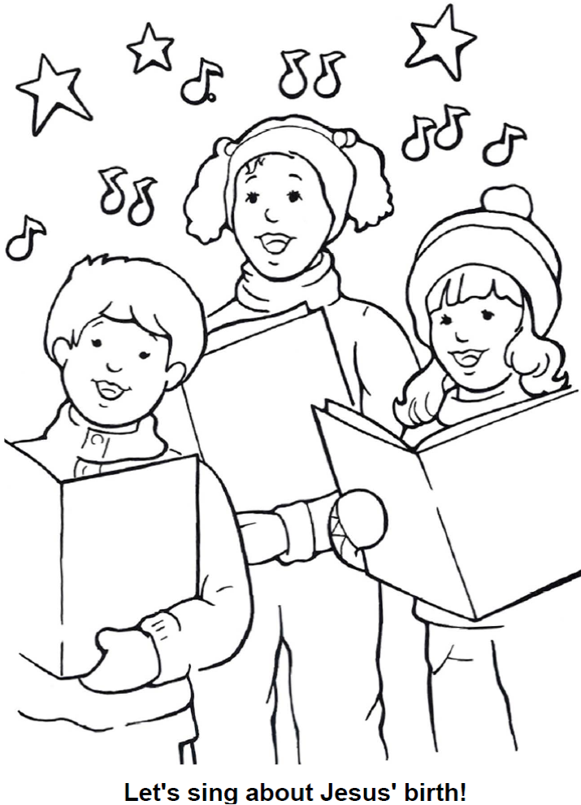

From Thru-the-Bible Coloring Pages © Standard Publishing.

Used by permission. Coloring Books may be purchased from  
Standard Publishing, www.standardpub.com, 1-800-323-5473.

Decoder Puzzle

Each number represents a letter of the alphabet. Replace  
each number in the puzzle with the corresponding letter  
to reveal the secret words.

