Crossword Puzzle

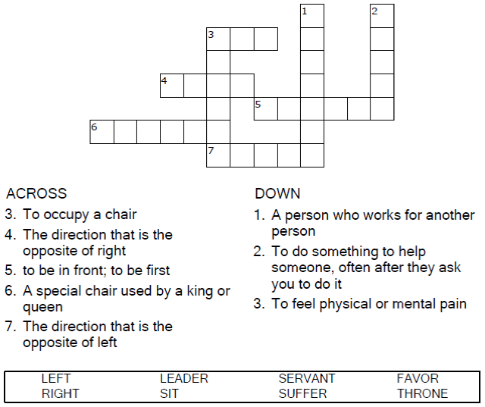

**

Copyright © Sermons4Kids, Inc.

May be reproduced for Ministry Use

**Children’s Worship Bulletin**



Mark 10:35-45

Word Search Puzzle

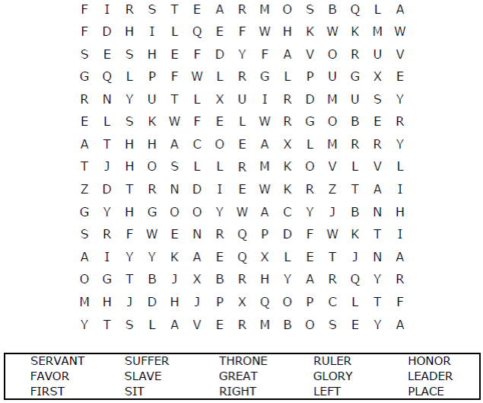  
  
**Church Name  
Address  
City**

Coloring Page

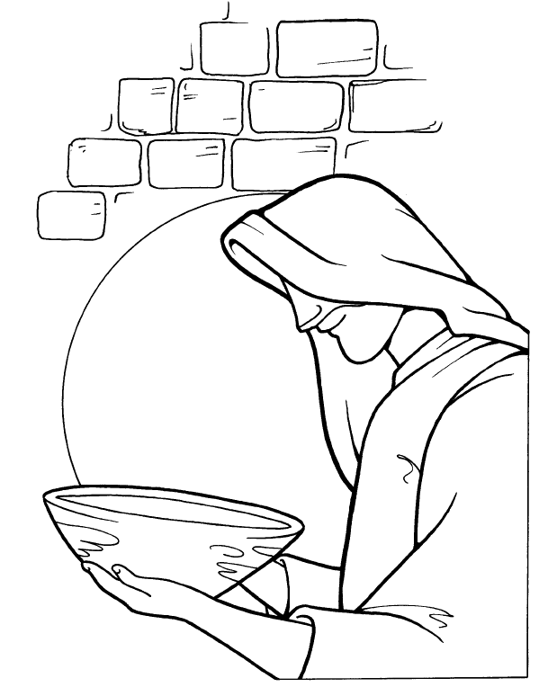

Whoever wants to become great among  
you must be your servant.  
Mark 10:43

Copyright © CalvaryCurriculum.com  
Used by Permission

Decoder Puzzle

Each number represents a letter of the alphabet. Substitute  
the correct letter for the numbers to reveal the coded words.

