Crossword Puzzle

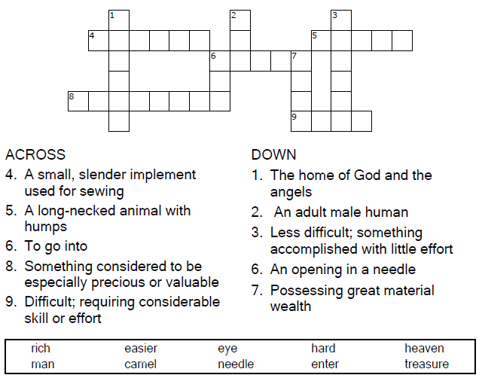

**

Copyright © Sermons4Kids, Inc.

May be reproduced for Ministry Use

**Children’s Worship Bulletin**



Mark 10:17-31

Word Search Puzzle

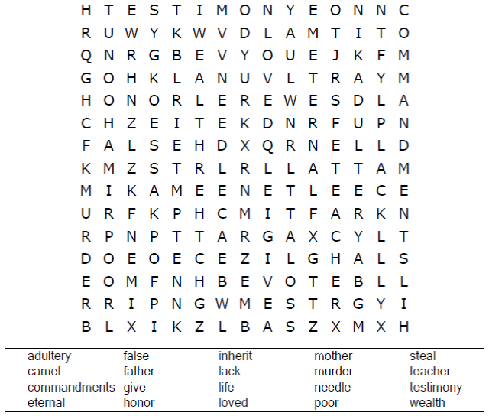  
  
**Church Name  
Address  
City**

Coloring Page

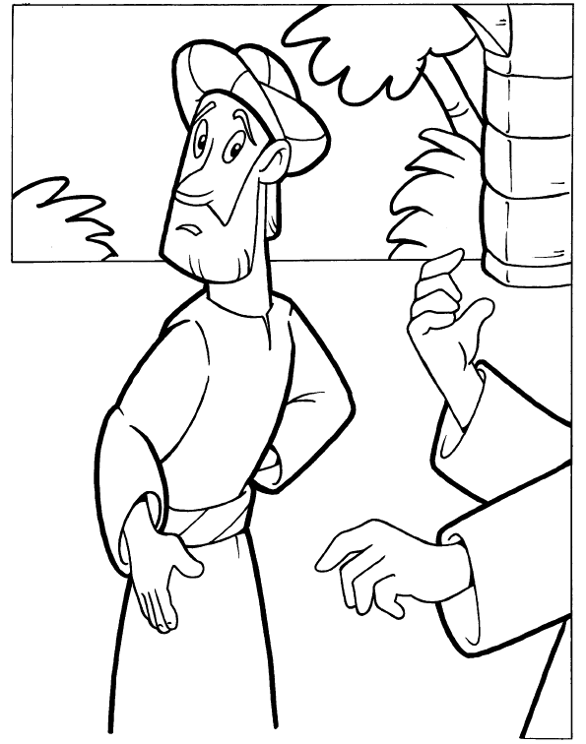

The Rich Young Ruler

Copyright © CalvaryCurriculum.com  
Used by Permission

Matching Quiz

