Crossword Puzzle

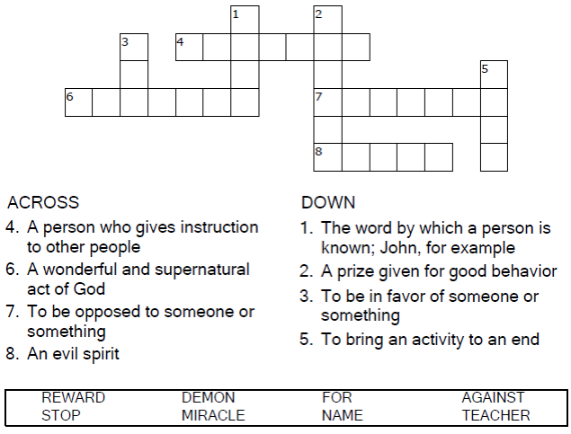



Copyright © Sermons4Kids, Inc.

May be reproduced for Ministry Use

**Children’s Worship Bulletin**



Mark 9:38-41

Word Search Puzzle

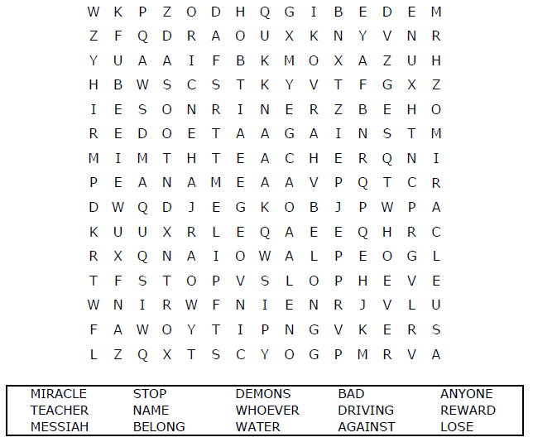  
  
**Church Name  
Address  
City**

Coloring Page

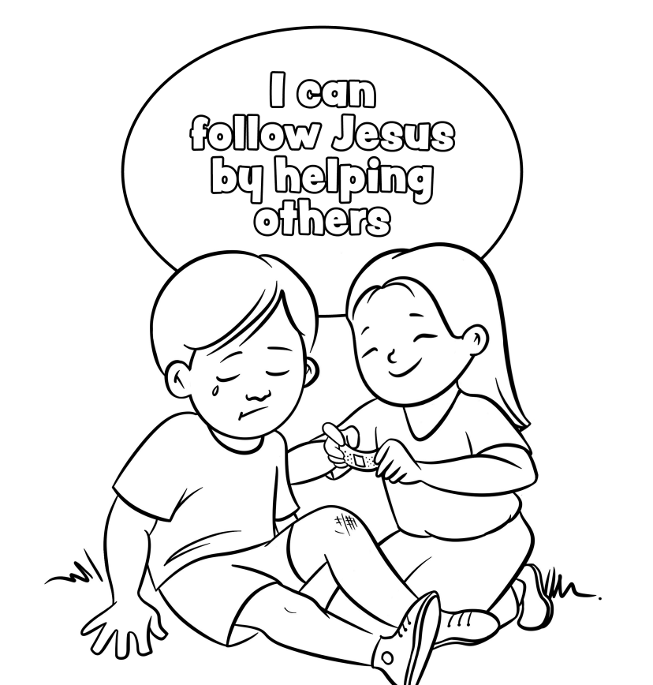

From Thru-the-Bible Coloring Pages for Ages 4-8. © 1986,1988 Standard Publishing.

Used by permission. Reproducible Coloring Books may be purchased from

Standard Publishing, www.standardpub.com, 1-800-543-1301.

Decoder Puzzle

Each number represents a letter of the alphabet.  
Substitute the correct letter for the numbers.

