Crossword Puzzle

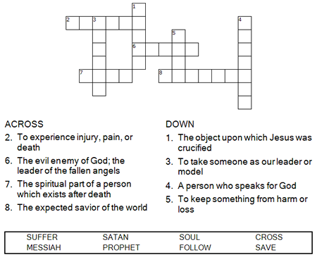

**

Copyright © Sermons4Kids, Inc.

May be reproduced for Ministry Use

Children’s Worship Bulletin



Mark 8:27-38

Word Search Puzzle

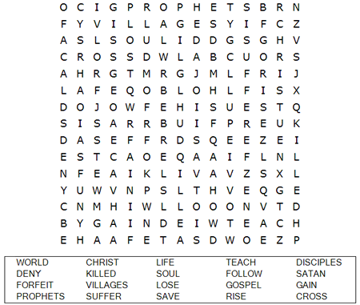

**Your Church Name Here**

Anytown, USA

Fill in the Blanks

Complete the sentences by filling in the blanks with the correct words from the word bank at the bottom of the page.

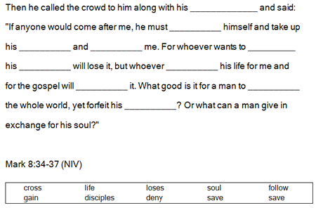

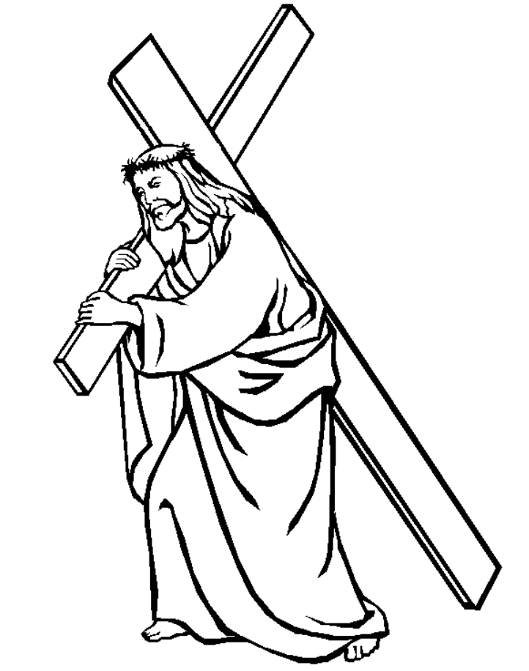

Maze Puzzle

Can you find the path to Jesus?

