Crossword Puzzle

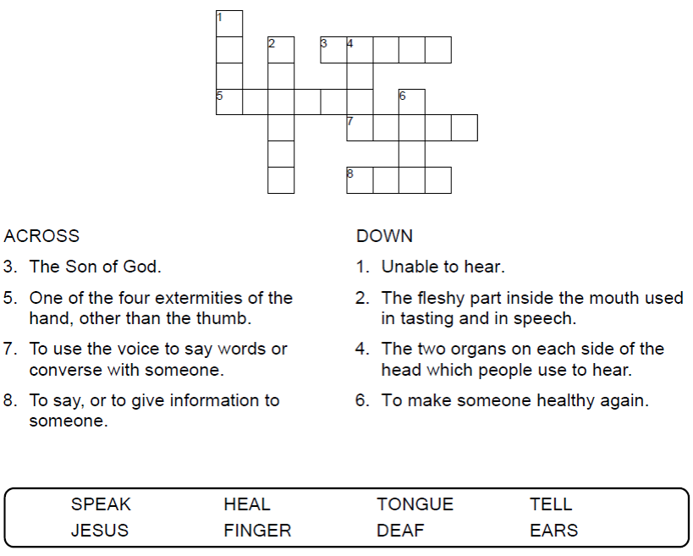

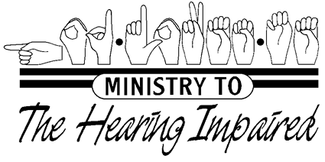

Copyright © Sermons4Kids, Inc.

May be reproduced for Ministry Use

Children’s Worship Bulletin



Mark 7:31-37

Word Search Puzzle

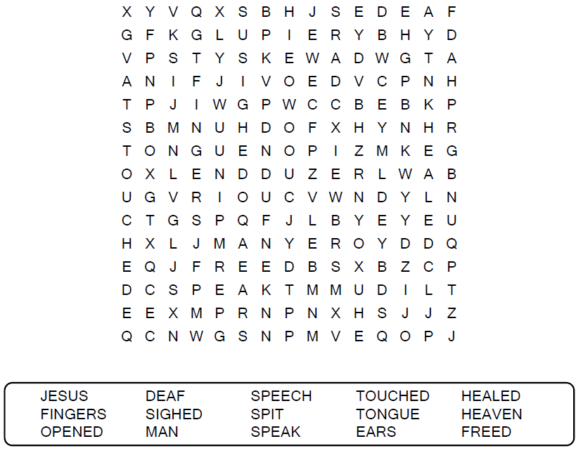

**Your Church Name Here**

Anytown, USA

Coloring Page

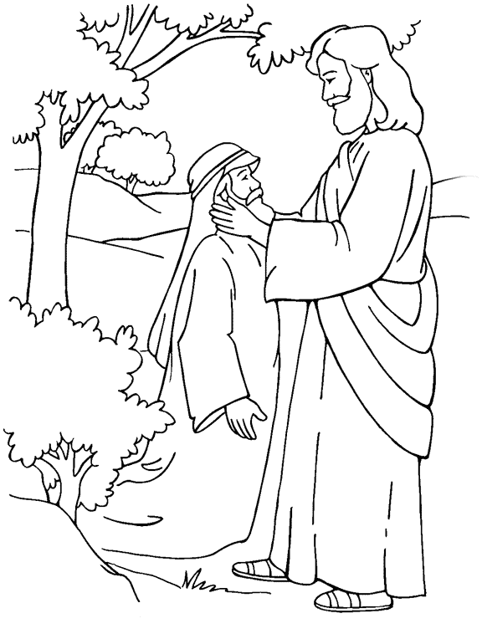

Jesus Heals a Deaf Man  
Mark 7:31-37

From Thru-the-Bible Coloring Pages © Standard Publishing.

Used by permission. Reproducible Coloring Books may be purchased

from Standard Publishing, www.standardpub.com, 1-800-323-5473.

Decoder Puzzle

Each number represents a letter of the alphabet. Substitute the correct letter for the numbers to reveal the words.

