Crossword Puzzle

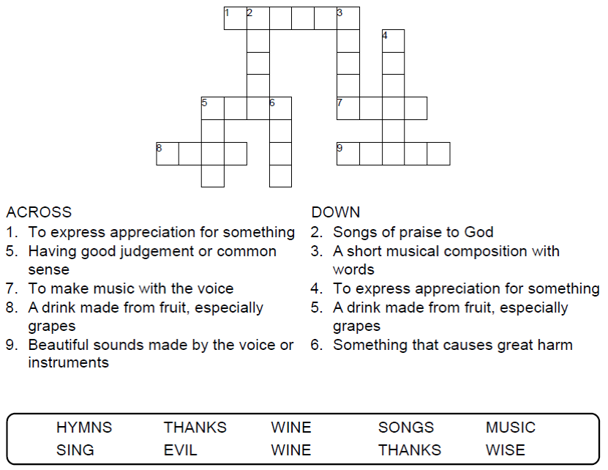



Copyright © Sermons4Kids, Inc.

May be reproduced for Ministry Use

**Children’s Worship Bulletin**



Ephesians 5:15-20

Word Search Puzzle

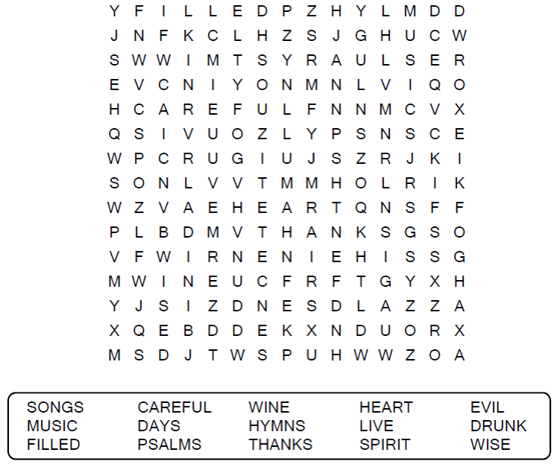  
  
**Church Name  
Address  
City**

Coloring Page

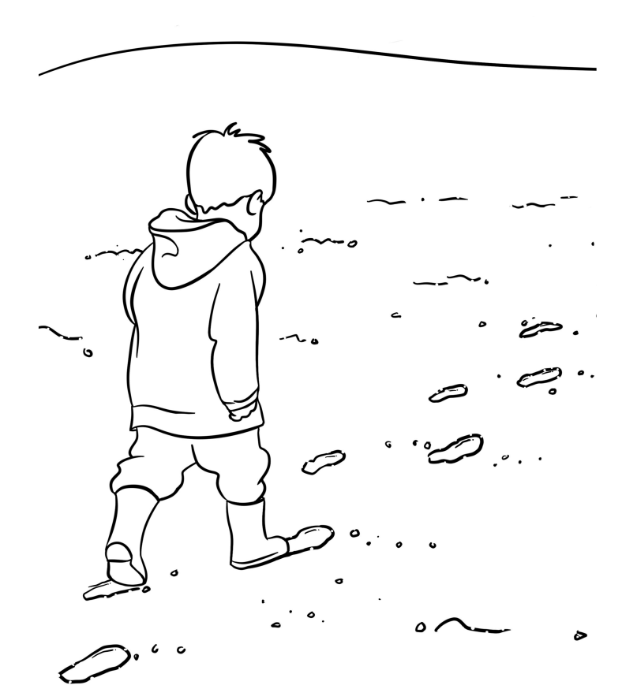

From Thru-the-Bible Coloring Pages. © 1986,1988 Standard Publishing.

Used by permission. Reproducible Coloring Books may be purchased from

Standard Publishing, www.standardpub.com, 1-800-323-5473.

Decoder Puzzle

Each number represents a letter of the alphabet.  
Substitute the correct letter for the numbers to  
reveal the correct word.

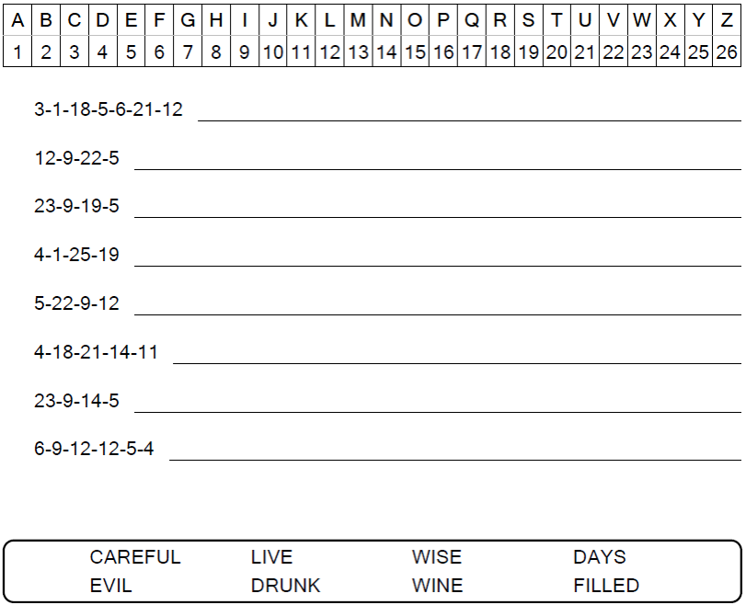

Be very careful, then, how you live — not as unwise  
but as wise, making the most of every opportunity,  
because the days are evil.

Ephesians 5:15-16 (NIV)