Crossword Puzzle

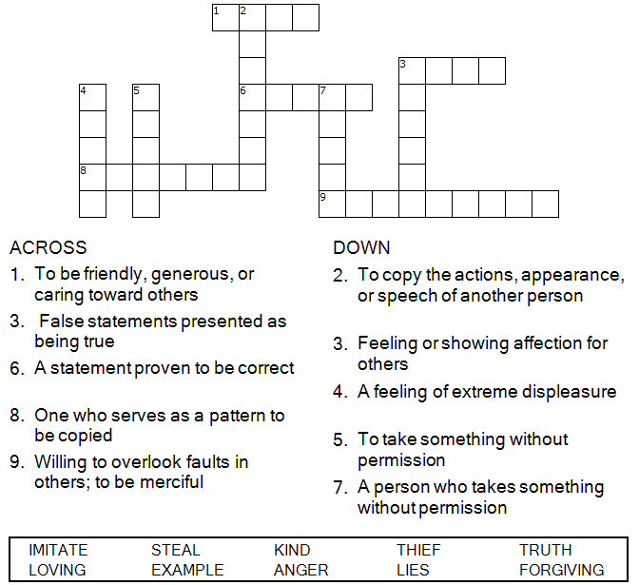

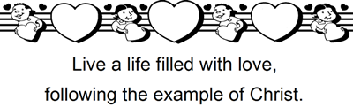

Copyright © Sermons4Kids, Inc.

May be reproduced for Ministry Use

Children’s Worship Bulletin



Ephesians 4:25-5:2

Word Search Puzzle

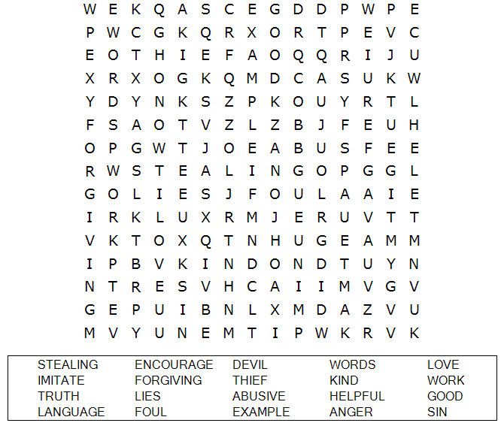

**Your Church Name Here**

Anytown, USA

Fill in the Blanks

Complete the sentences by filling in the blanks with the correct words from the word bank at the bottom of the page. You can check you answers in Ephesians 4:31-5:2 (NLT)

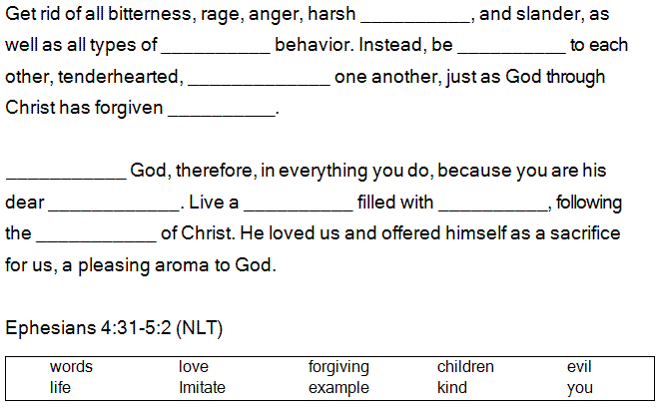

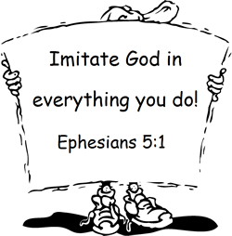

Unscramble the words of these sentences. These are the things we need to do to live a life that is pleasing to God. Be sure to capitalize proper names and words such as Lord and God. You can check your answers in Ephesians 4:25-5:2.

Scrambled Sentences

When they had all had enough to eat, he said to his disciples, "Gather the pieces that are left over. Let nothing be wasted." So they gathered them and filled twelve baskets with the pieces of the five barley loaves left over by those who had eaten.

John 6:12-13 (NIV)

