Crossword Puzzle

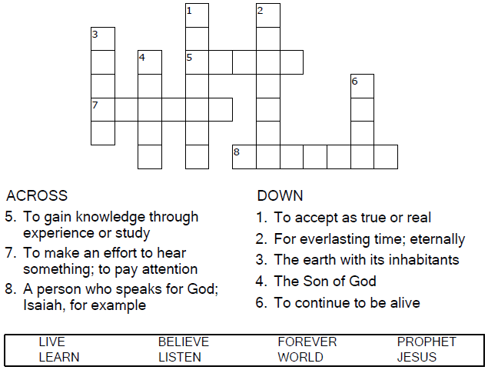

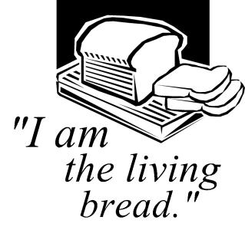

Copyright © Sermons4Kids, Inc.

May be reproduced for Ministry Use

**Children’s Worship Bulletin**



John 6:41-51

Word Search Puzzle

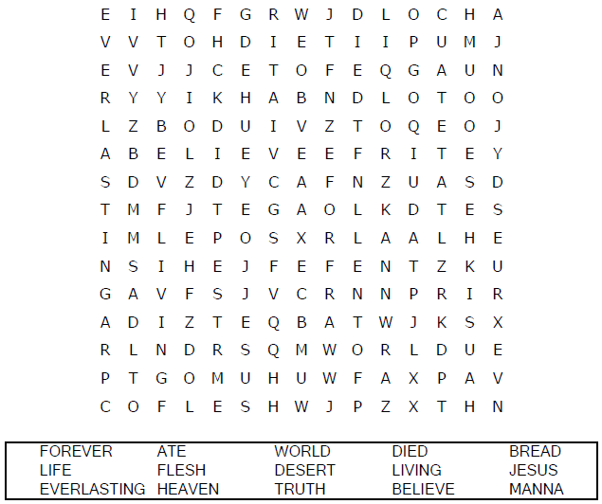  
  
**Church Name  
Address  
City**

Coloring Page

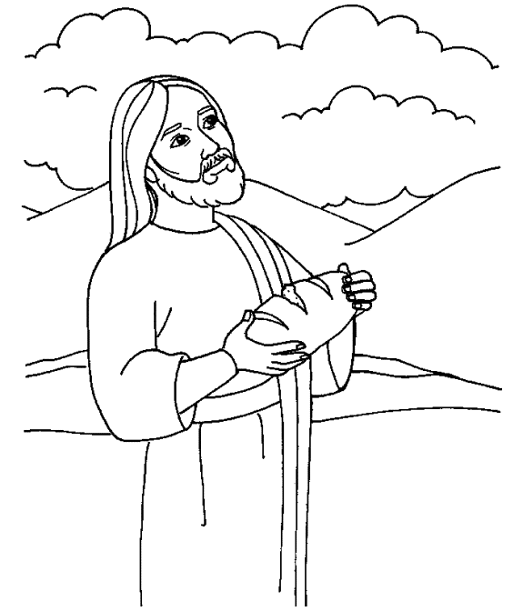

“I am the living bread that came down from heaven.  
Whoever eats this bread will live forever.”  
John 6:51

Decoder Puzzle

Each number represents a letter of the alphabet.  
Substitute the correct letter for the numbers to  
reveal the coded words.

