Crossword Puzzle

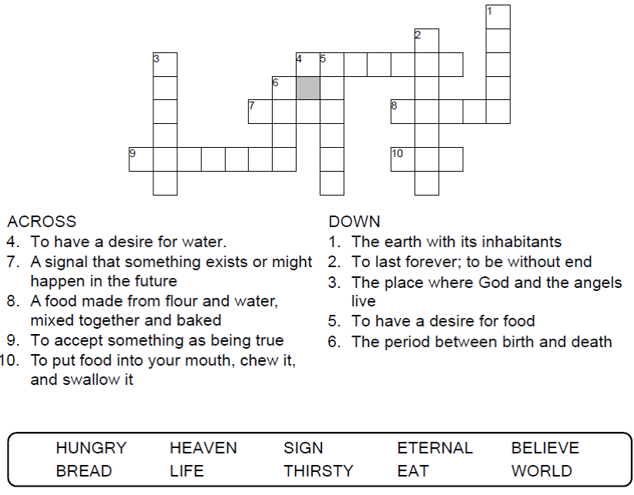

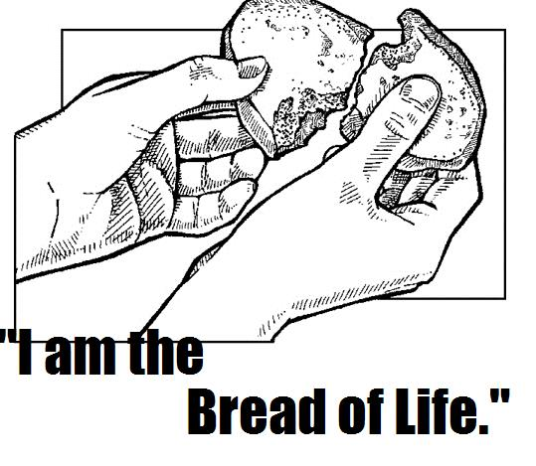

Copyright © Sermons4Kids, Inc.

May be reproduced for Ministry Use

Children’s Worship Bulletin



John 6:24-35

Word Search Puzzle

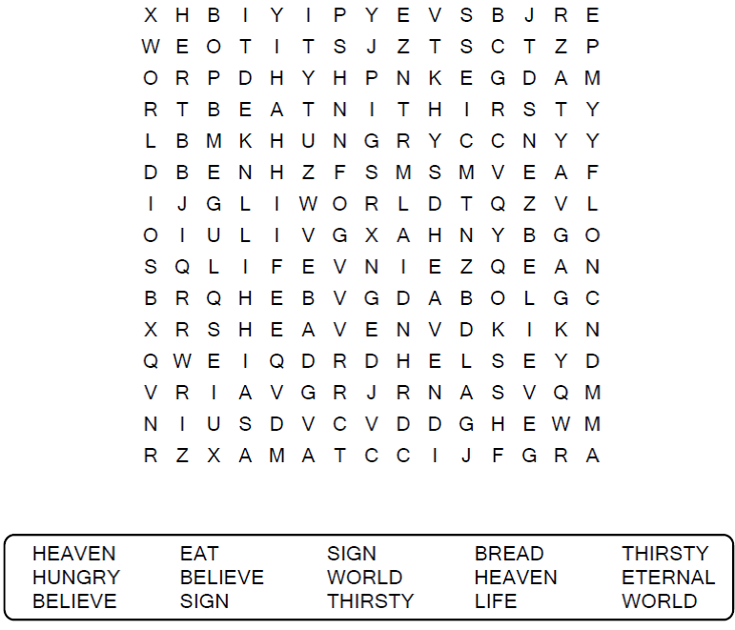

**Your Church Name Here**

Anytown, USA

Coloring Page

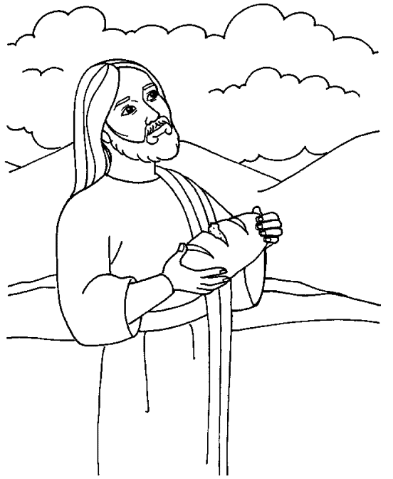

Jesus replied, “I am the bread of life. Whoever comes to me will never be hungry again.  
John 6:35

Fill in the Blanks

A word has been removed from each sentence  
and listed in the word bank below. Use the   
listed words to fill in the blanks.

