Crossword Puzzle

Trusting Jesus

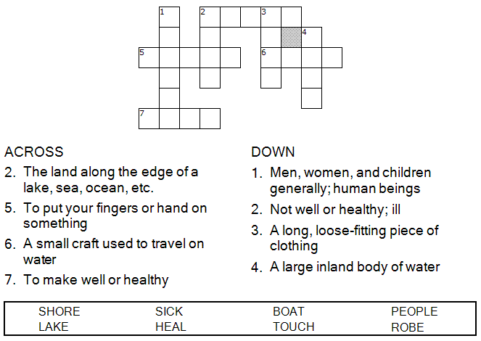

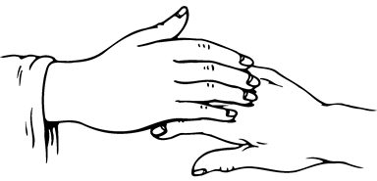

Copyright © Sermons4Kids, Inc.

May be reproduced for Ministry Use

Children’s Worship Bulletin



Mark 6:53-56

Word Search Puzzle

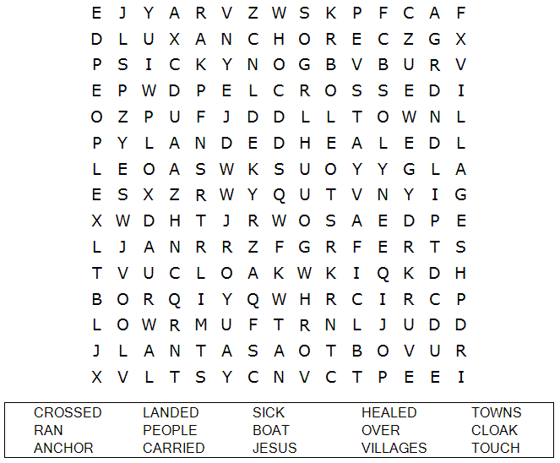

**Your Church Name Here**

Anytown, USA

Fill in the Blanks

Complete the sentences by filling in the blanks  
with the correct words from the word bank at  
the bottom of the page.

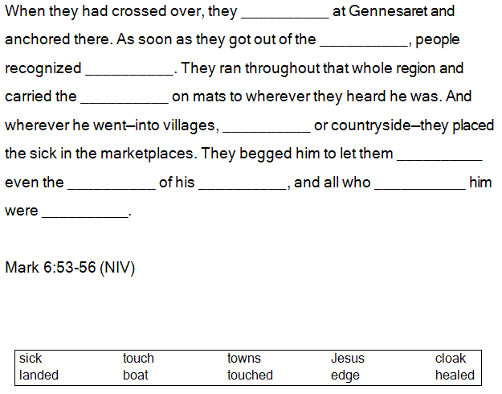

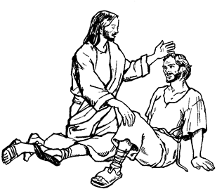

Color Me

They begged him to let them touch even the edge of his cloak,  
and all who touched him were healed.  
Mark 6:56

