Crossword Puzzle





Copyright © Sermons4Kids, Inc.

May be reproduced for Ministry Use

**Children’s Worship Bulletin**



Mark 6:1-6

Word Search Puzzle

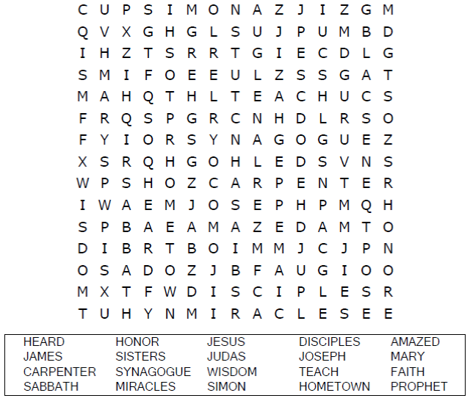

**Your Church Name**

**Any Town, Anywhere**

Coloring Page

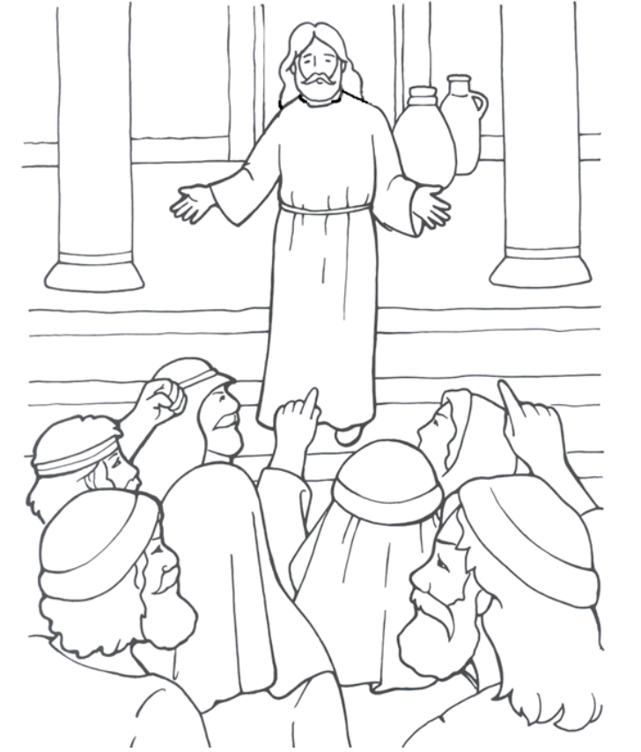

Jesus is powerful. He can change the weather.

From Thru-the-Bible Coloring Pages for Ages 4-8. © 1986,1988  
Standard Publishing. Used by permission. Reproducible Coloring Books may be  
purchased from Standard Publishing, www.standardpub.com, 1-800-543-1301.

Decoder Puzzle

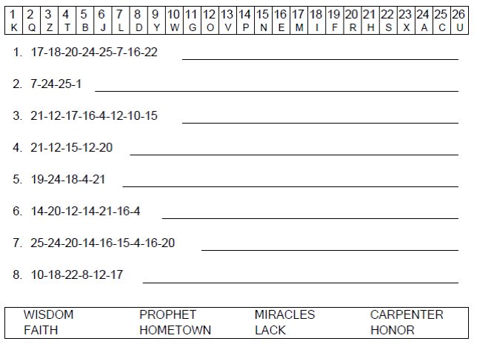



Praying for rain? Don’t forget your umbrella!