Crossword Puzzle

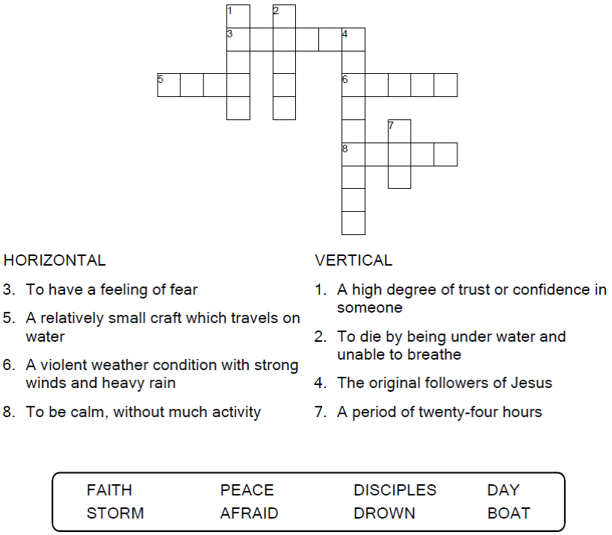

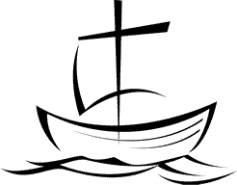

Copyright © Sermons4Kids, Inc.

May be reproduced for Ministry Use

Children’s Worship Bulletin



Mark 4:35-41

Word Search Puzzle

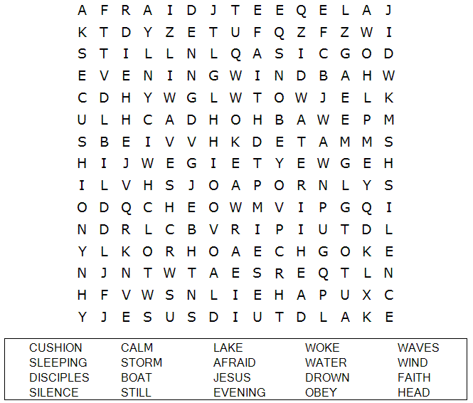

**Your Church Name Here**

Anytown, USA

Coloring Page

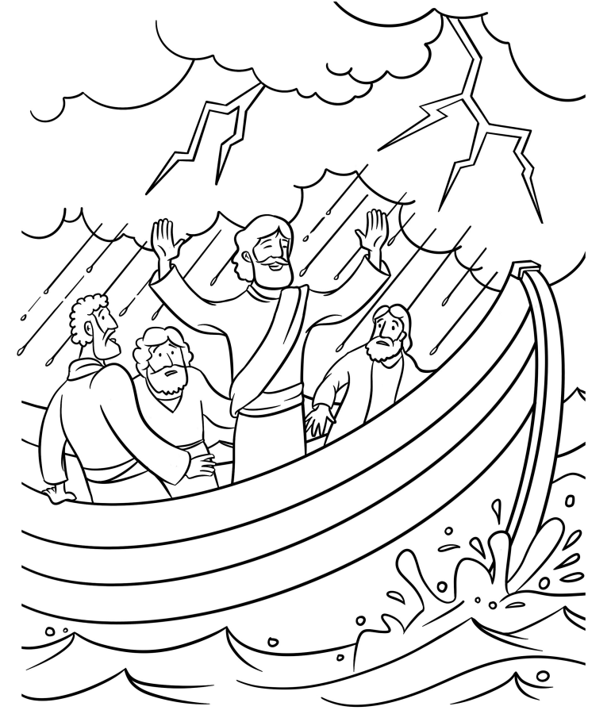

Jesus Calms the Storm

Word Jumble

Unscramble each word and then place the numbered letters  
in the numbered boxes at the bottom to reveal the answer.

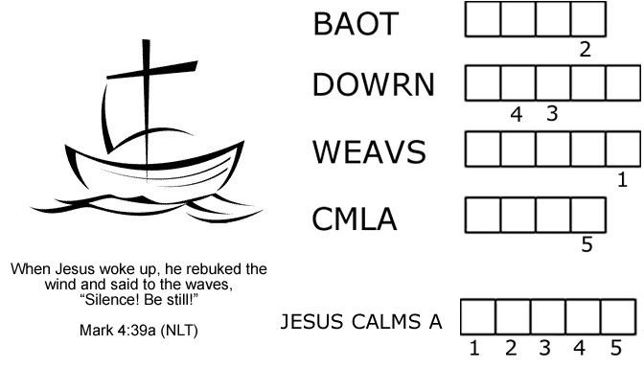

The disciples were absolutely terrified. “Who is this man?” they asked each other. “Even the  
wind and waves obey him!”

Mark 4:41 (NLT)

|  |
| --- |
| **PUZZLE CLUES** |
| 1. Jesus and his disciples got in a ________. |
| 2. The disciples were afraid that they were going to _________. |
| 3. Jesus spoke to the wind and the __________. |
| 4. After Jesus spoke, the sea became __________. |
| Answer: There was a fierce ___________ on the sea. |
| Check your answers in Mark 4:35-41 (NIV) |