Crossword Puzzle

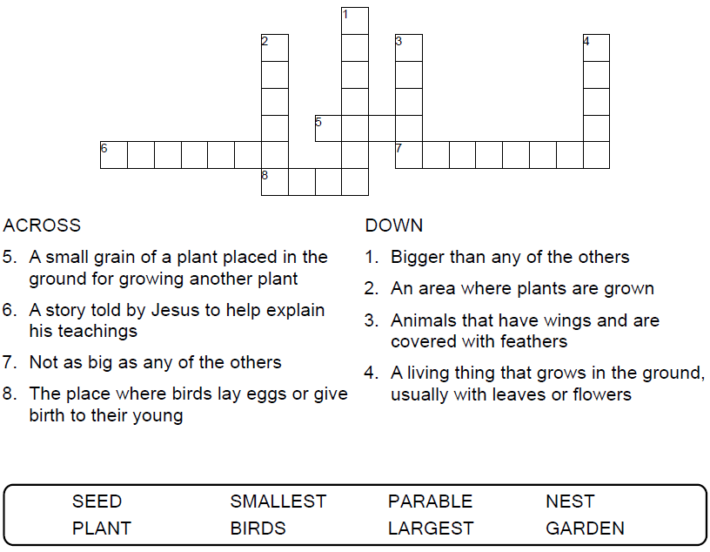



Copyright © Sermons4Kids, Inc.

May be reproduced for Ministry Use

**Children’s Worship Bulletin**



Mark 4:30-34

Word Search Puzzle

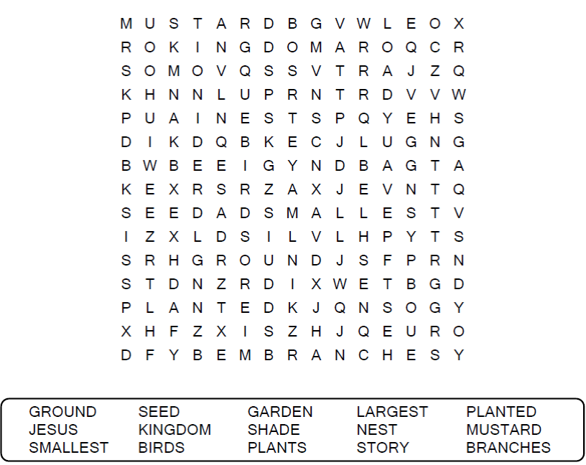

**Your Church Name**

**Any Town, Anywhere**

Coloring Page

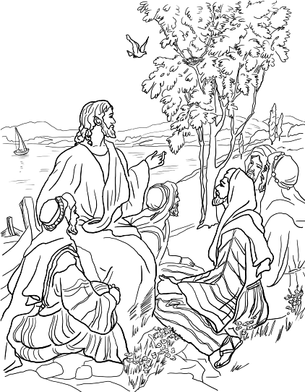

The Parable of the Mustard Seed

Mark 4:30-34

Fill in the Blanks

A word has been removed from each sentence and listed  
below the sentences. Use the listed words to fill the blanks.

