Crossword Puzzle

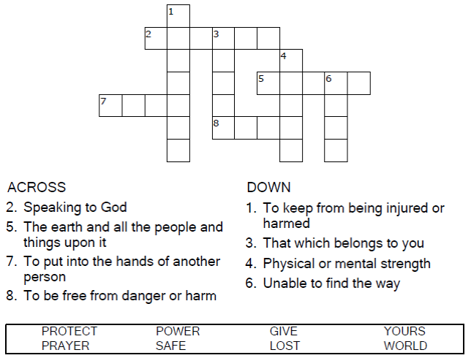

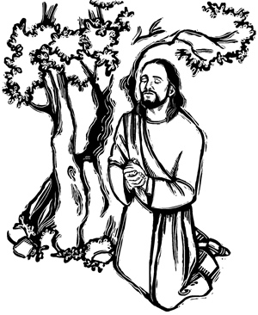

Copyright © Sermons4Kids, Inc.

May be reproduced for Ministry Use

Children’s Worship Bulletin



Jesus Prays for His Disciples

John 17:6-19

Word Search Puzzle

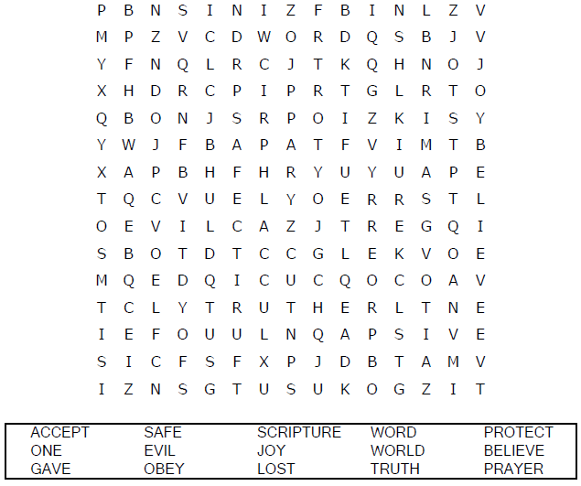

**Your Church Name Here**

Anytown, Anywhere

Color Me!

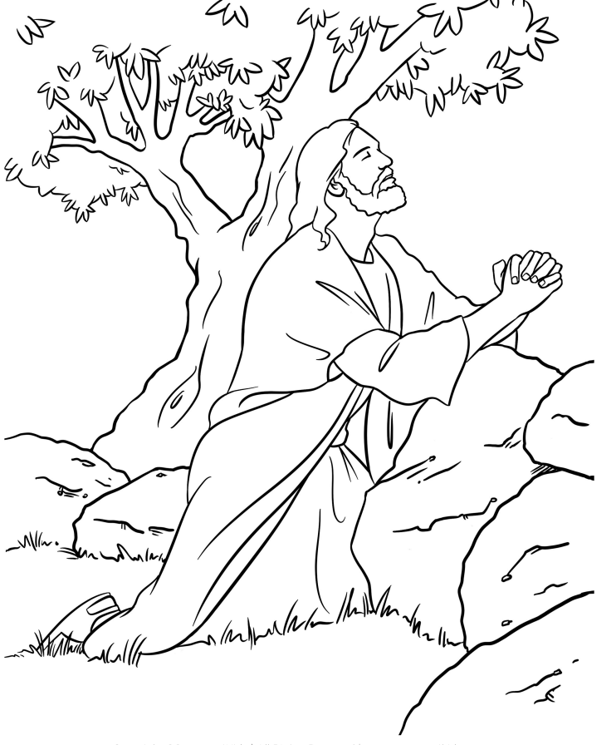

**Jesus Prays for His Disciples**

Maze Puzzle

Can you find your way home?

