Crossword Puzzle

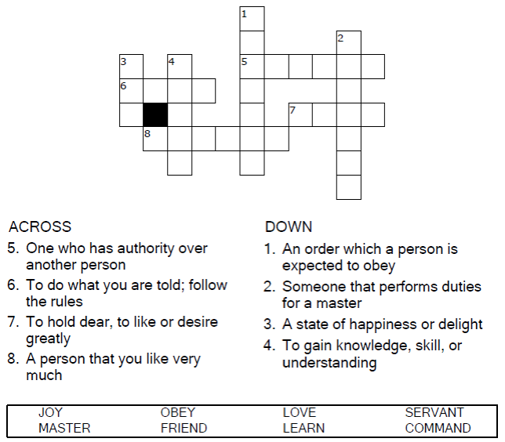

**

Copyright © Sermons4Kids, Inc.

May be reproduced for Ministry Use

Children’s Worship Bulletin



John 15:9-17

Word Search Puzzle

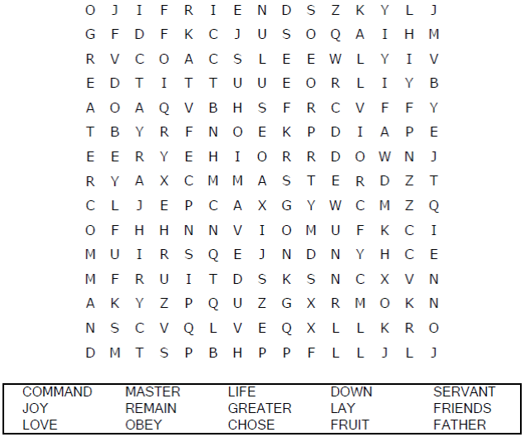

**Your Church Name Here**

Anytown, Anywhere

Color Me!

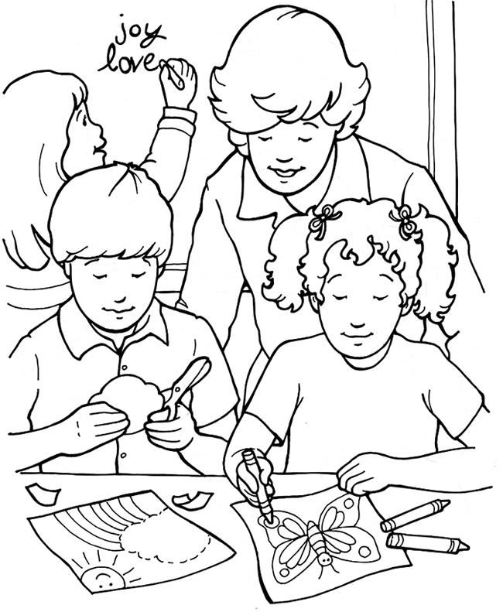

**That Your Joy May Be Full**

From Thru-the-Bible Coloring Pages for Ages 4-8. © 1986,1988  
Standard Publishing. Used by permission. Reproducible Coloring Books may be  
purchased from Standard Publishing, www.standardpub.com, 1-800-543-1301.

Decoder Puzzle

Each number represents a letter of the alphabet. Substitute  
the correct letter for the numbers to reveal the coded words.

