Crossword Puzzle

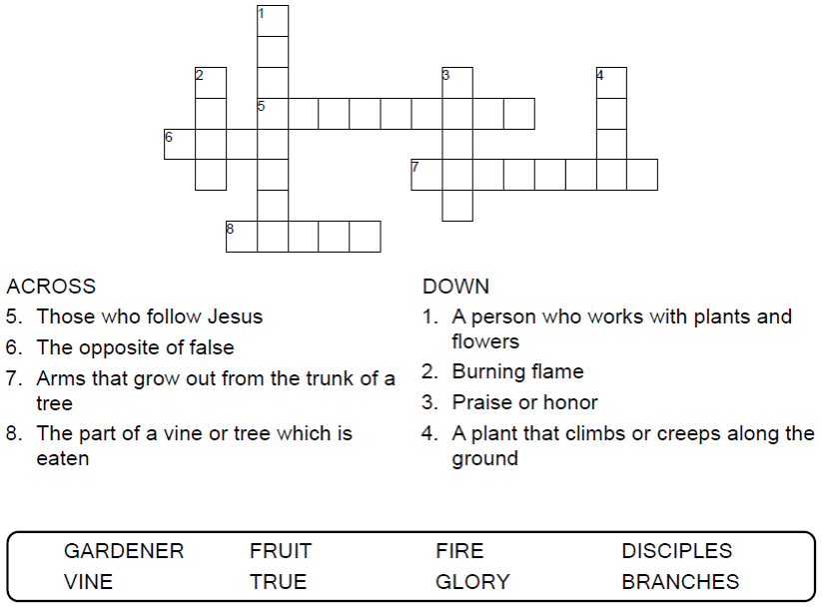

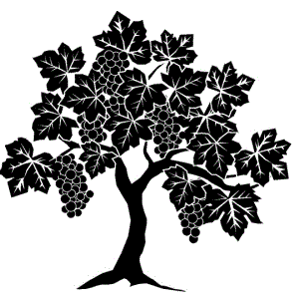

Copyright © Sermons4Kids, Inc.

May be reproduced for Ministry Use

Children’s Worship Bulletin



John 15:1-8

Word Search Puzzle

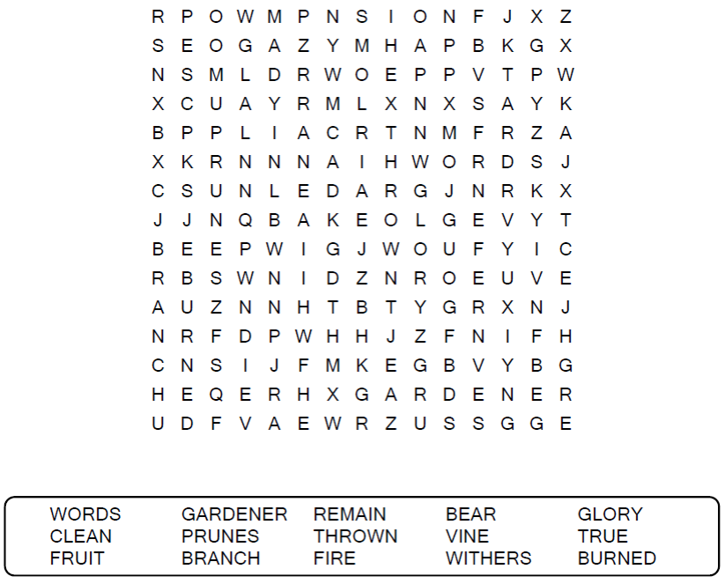

**Your Church Name Here**

Anytown, USA

Color Me!

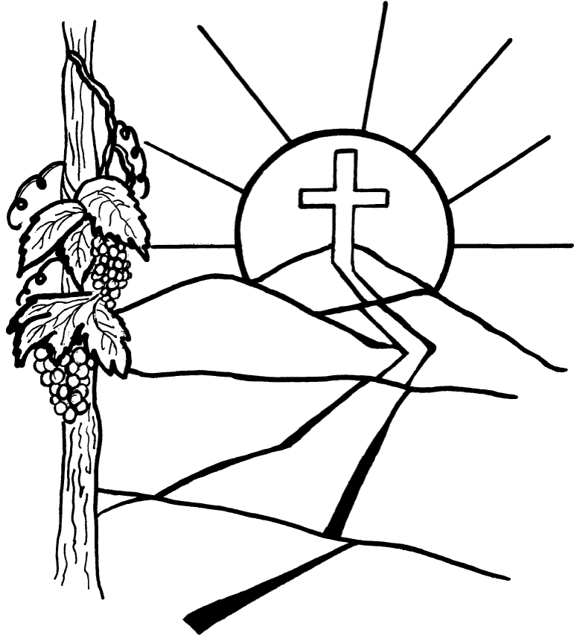

"I am the vine; you are the branches. If a man remains in me and I  
in him, he will bear much fruit; apart from me you can do nothing."  
John 15:5 (NIV)

Copyright © CalvaryCurriculum.com  
Used by Permission

Decoder Puzzle

