Crossword Puzzle

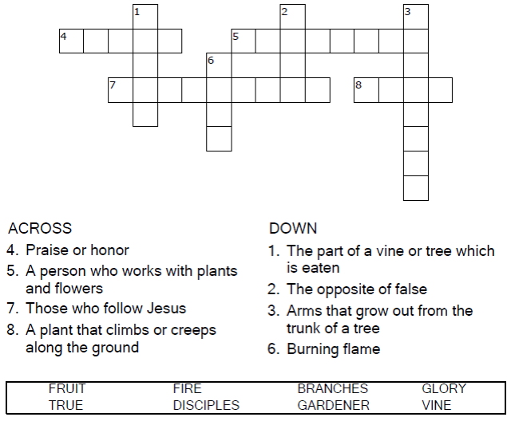

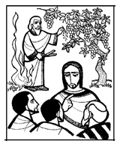

Copyright © Sermons4Kids, Inc.

May be reproduced for Ministry Use

Children’s Worship Bulletin



John 15:1-8

Word Search Puzzle

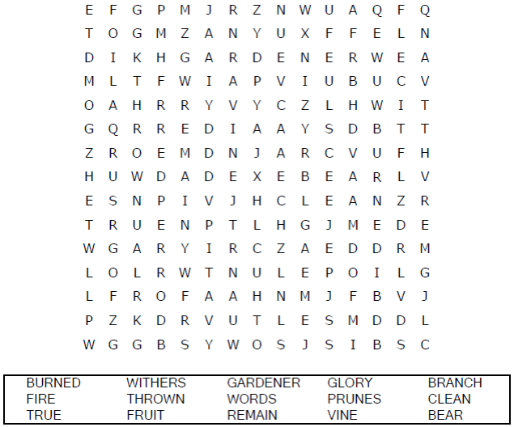

**Your Church Name Here**

Anytown, Anywhere

Color Me!

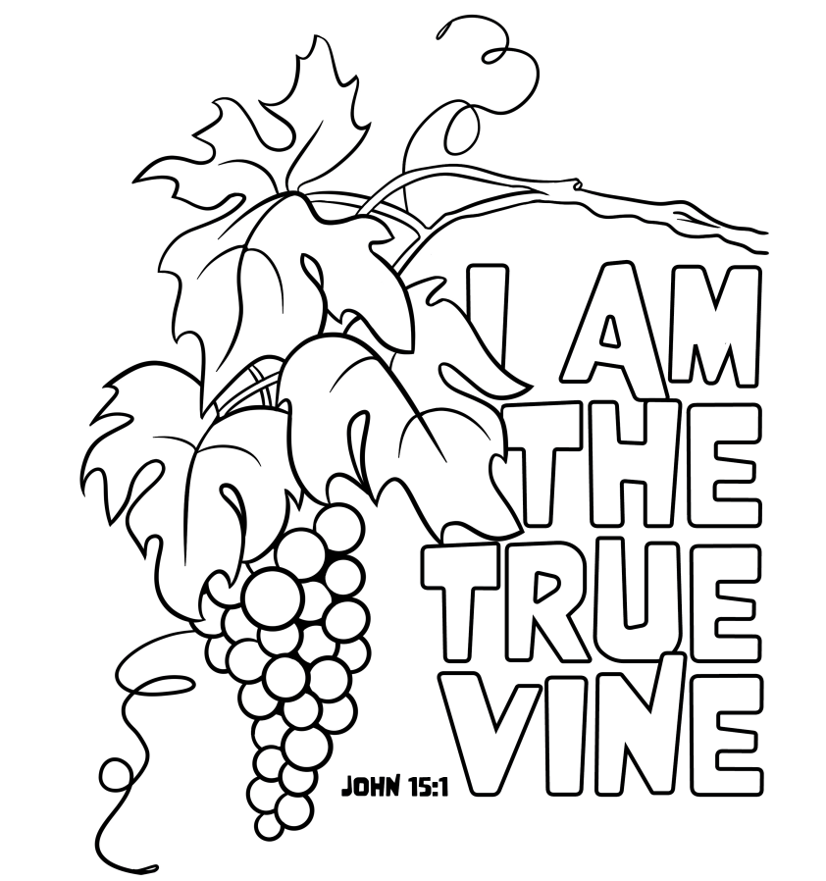

""I am the vine; you are the branches. If a man remains in me and I in him, he will bear much fruit; apart from me you can do nothing. This is to my Father's glory, that you bear much fruit, showing yourselves to be my disciples."

John 15:5, 8 (NIV)

Copyright © CalvaryCurriculum.com  
Used by Permission

Decoder Puzzle

