Crossword Puzzle

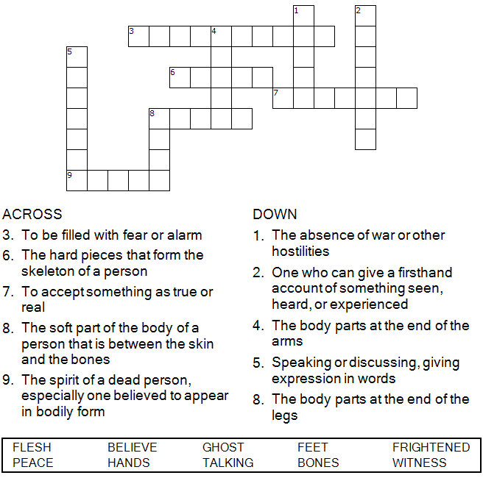



Copyright © Sermons4Kids, Inc.

May be reproduced for Ministry Use

Children’s Worship Bulletin



Luke 24:36-48

Word Search Puzzle

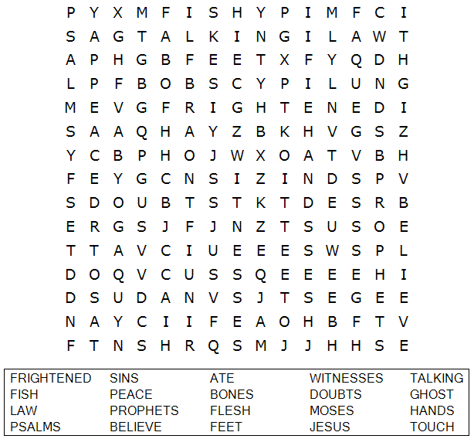

**Your Church Name Here**

Anytown, USA

Multiple Choice Quiz

Choose the word that best matches the definition.  
Check your answers in Luke 24:36-48 (NIV)

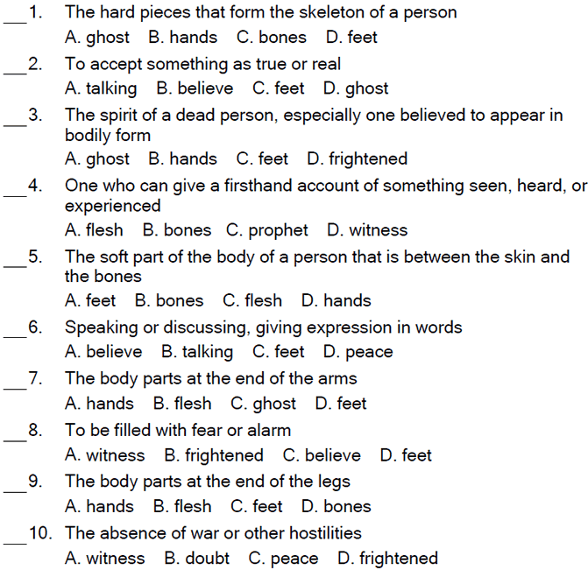

He told them, "This is what is written: The Christ will suffer  
and rise from the dead on the third day, and repentance and forgiveness of sins will be preached in his name to all nations, beginning at Jerusalem. You are witnesses of these things." Luke 24:46-48 (NIV)

Decoder Puzzle

Each number represents a letter of the alphabet. Substitute the correct letter for the numbers to reveal the coded words.

