Crossword Puzzle

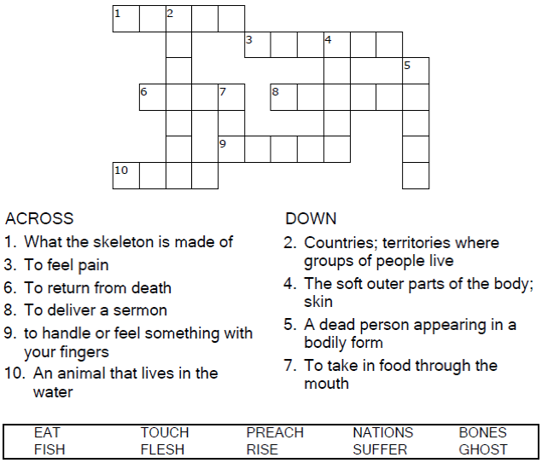

**

Copyright © Sermons4Kids, Inc.

May be reproduced for Ministry Use

Children’s Worship Bulletin



Luke 24:36-48

Word Search Puzzle

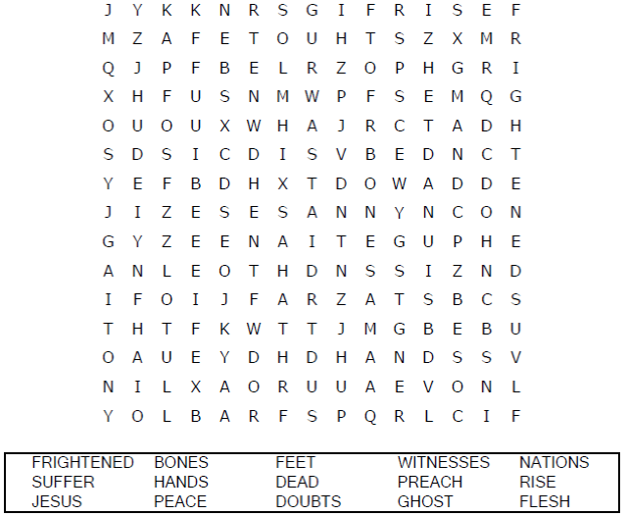

**Your Church Name Here**

Anytown, Anywhere

Coloring Page

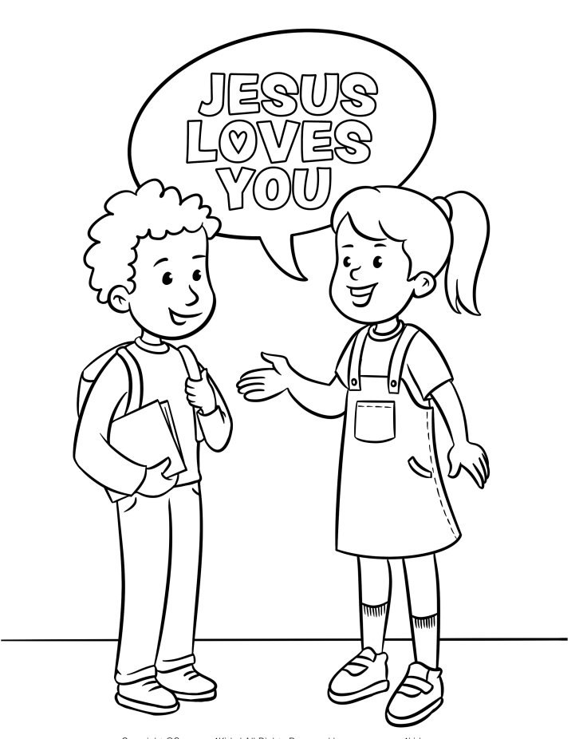

I can tell my friends about Jesus.

Maze Puzzle

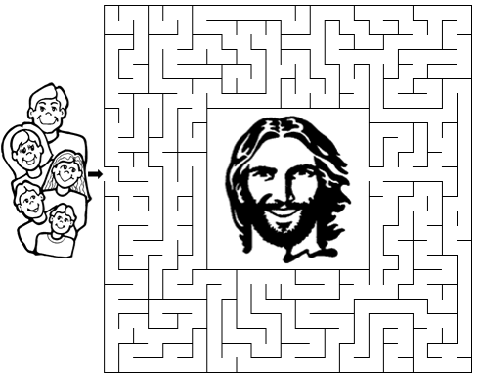

He told them, "This is what is written: The Christ will suffer  
and rise from the dead on the third day, and repentance  
and forgiveness of sins will be preached in his name  
to all nations, beginning at Jerusalem.”

Luke 24:46-47 (NIV)

