Crossword Puzzle

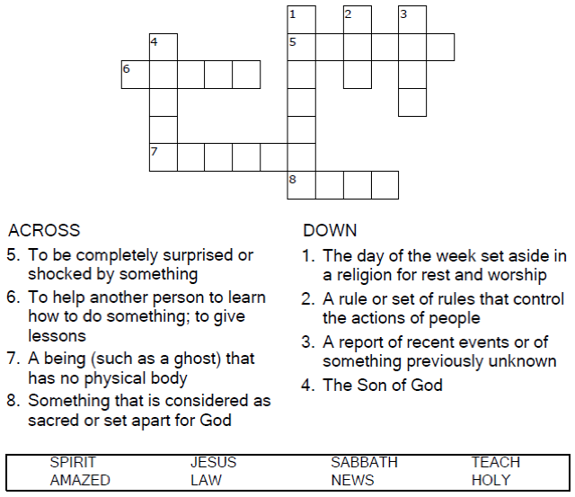

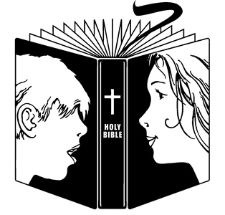

Copyright © Sermons4Kids, Inc.

May be reproduced for Ministry Use

Children’s Worship Bulletin



Mark 1:21-28

Word Search

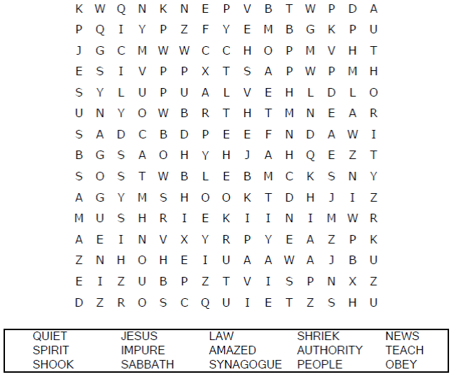

**Your Church Name Here**Any Town, Anywhere

Decoder Puzzle

Each number represents a letter of the alphabet.  
Substitute the correct letter for the numbers  
to reveal the coded words.

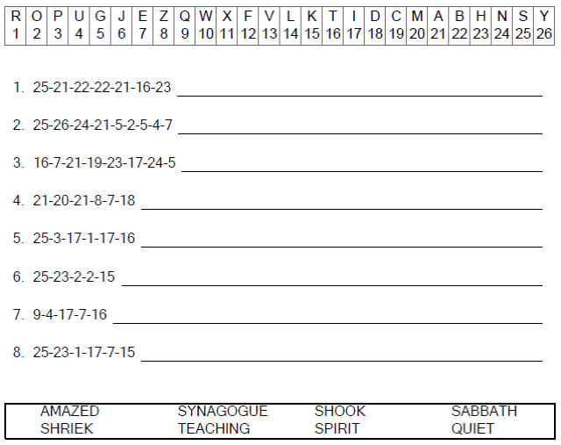



Color Me

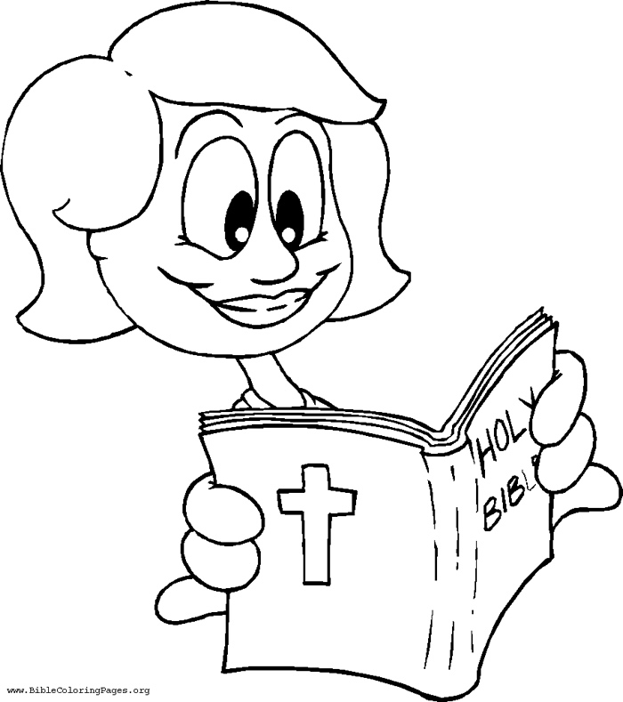

Copyright © www.savetzpublishing.com  
Used by Permission

Reading God's Word