Crossword Puzzle

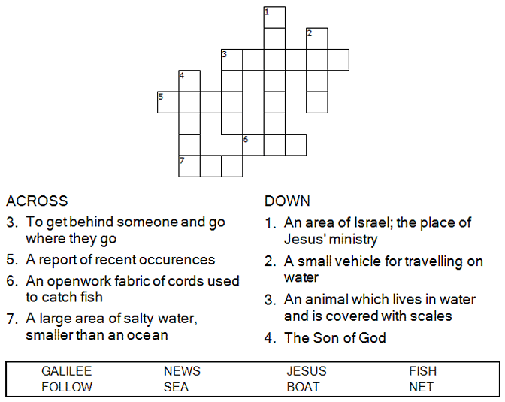



Copyright © Sermons4Kids, Inc.

May be reproduced for Ministry Use

Children’s Worship Bulletin



Mark 1:14-20

Word Search

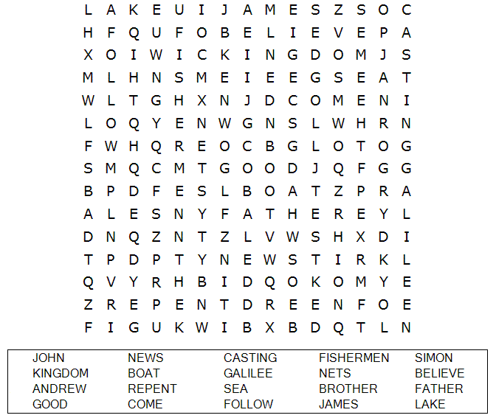

**Your Church Name Here**Anytown, Anywhere

Dot to Dot Puzzle

Connect the dots to complete the picture.

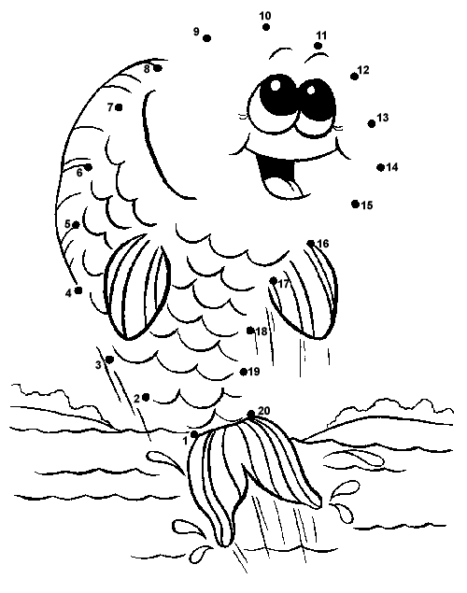  
From Thru-the-Bible Coloring Pages for Ages 4-8. © 1986,1988 Standard Publishing.

Used by permission. Reproducible Coloring Books may be purchased from

Standard Publishing, www.standardpub.com, 1-800-543-1301.

FISHING FOR PEOPLE

Color Me

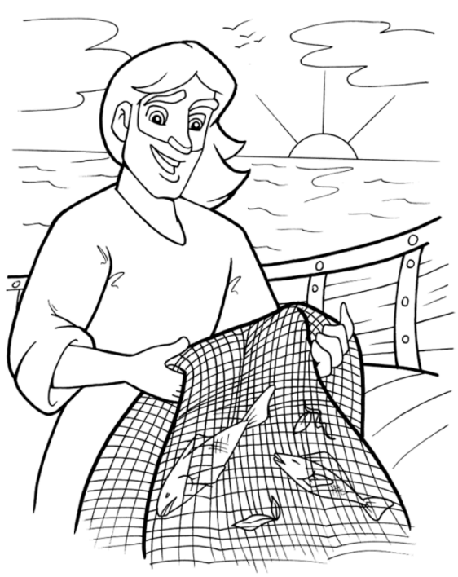

Jesus called out to them, "Come, be my disciples,

and I will show you how to fish for people!"

Mark 1:17 (NLT)