Crossword Puzzle

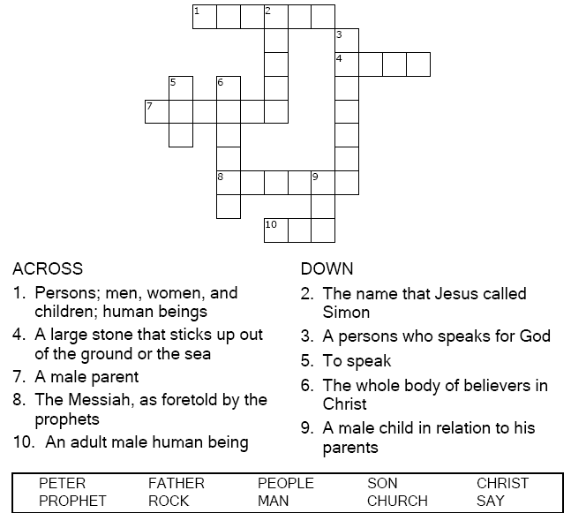



Copyright © Sermons4Kids, Inc.

May be reproduced for Ministry Use

**Children’s Worship Bulletin**



Matthew 16:13-20

Word Search Puzzle

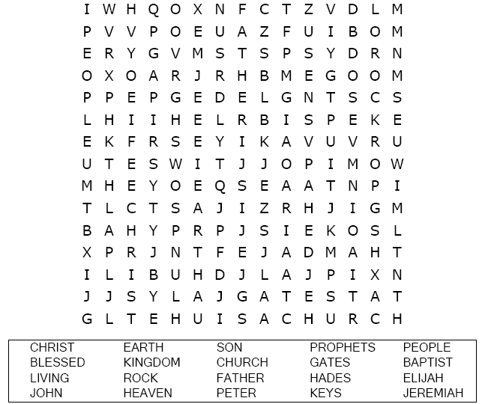  
  
**Your Church’s Name  
Address  
City, State**

Coloring Page

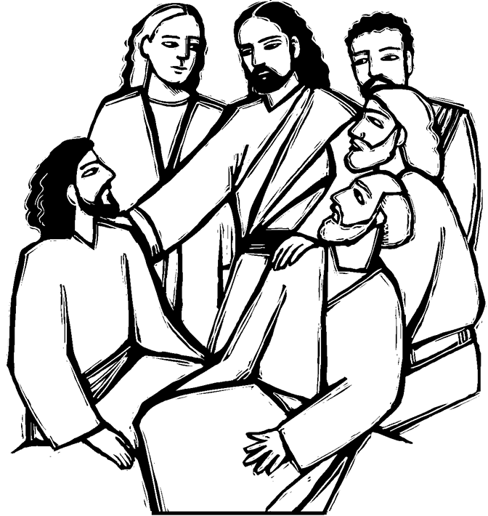  
  
“But what about you? Who do you say I am?”  
Matthew 16:15

image.png

Decoder Puzzle

Each number represents a letter of the alphabet. Substitute  
the correct letter for the numbers to reveal the codded words.

