Crossword Puzzle

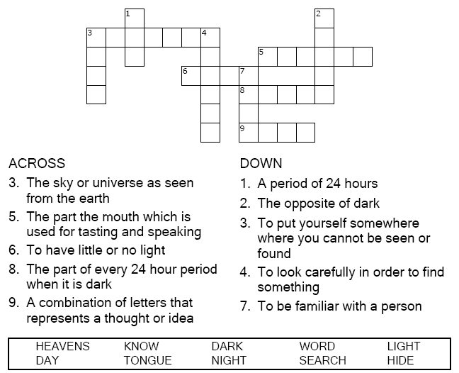



Copyright © Sermons4Kids, Inc.

May be reproduced for Ministry Use

**Children’s Worship Bulletin**



Psalm 139:1-12

Word Search Puzzle

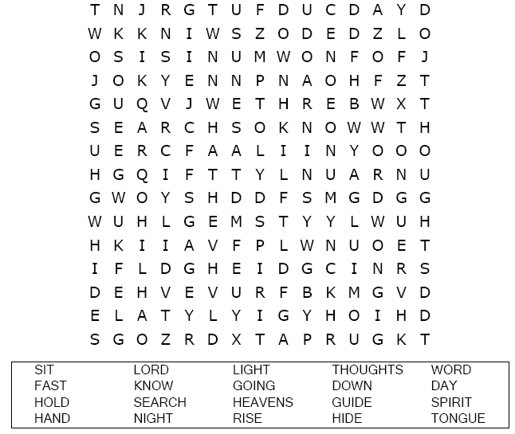  
  


Coloring Page

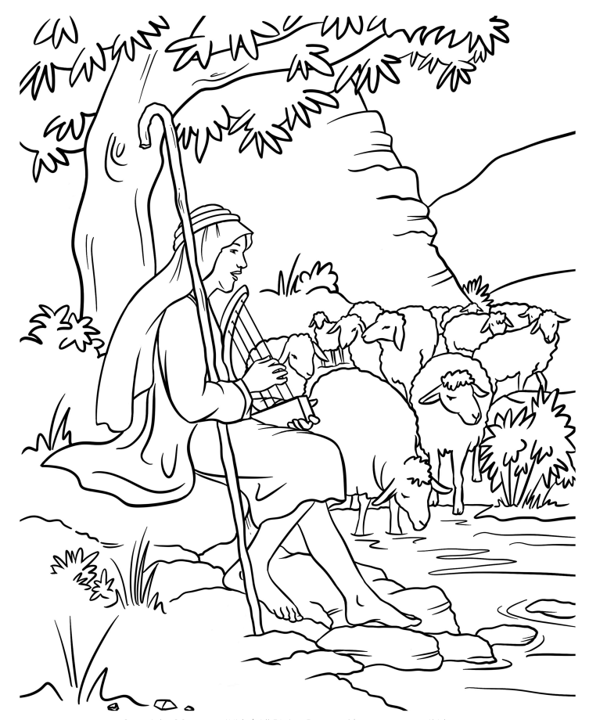

Multiple Choice Quiz

Choose the word that best matches the definition.

