Crossword Puzzle

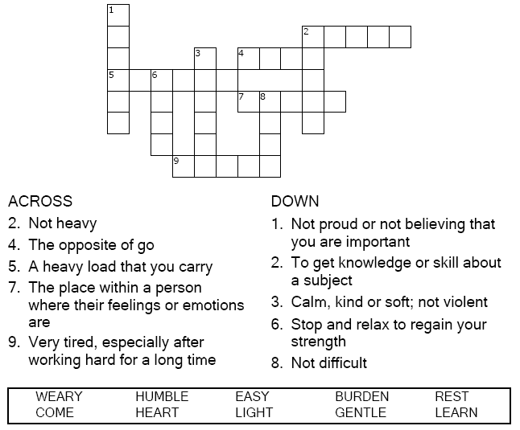

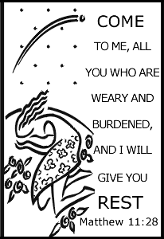

Copyright © Sermons4Kids, Inc.

May be reproduced for Ministry Use

**Children’s Worship Bulletin**



Matthew 11:28-30

Word Search Puzzle

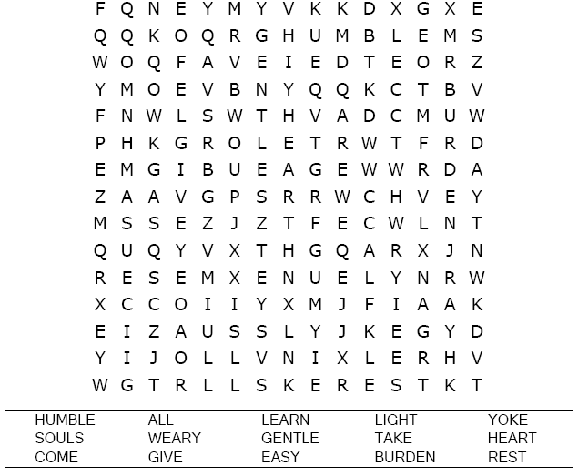  
  
**image.png**

Coloring Page

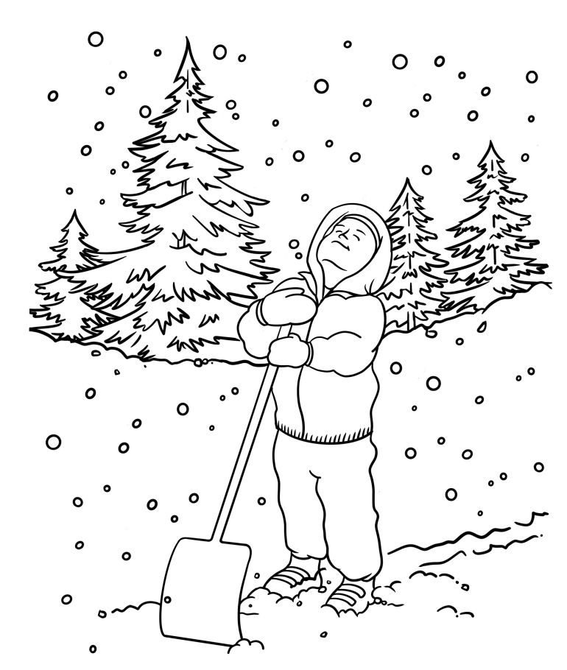

God Helps Me

Decoder Puzzle

Each number represents a letter of the alphabet. Substitute  
the correct letter for the numbers to reveal the coded words.

