Crossword Puzzle

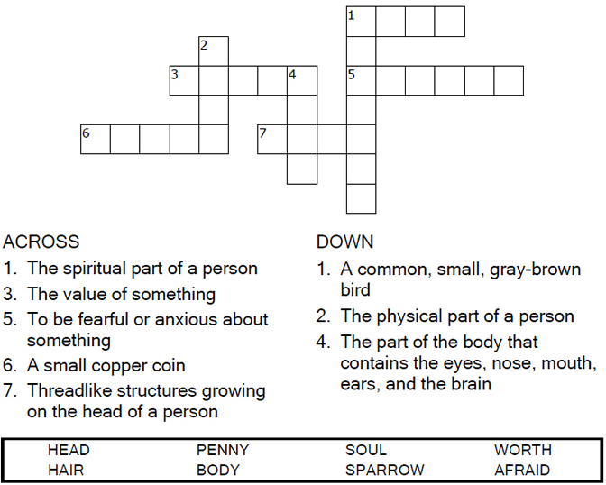



Copyright © Sermons4Kids, Inc.

May be reproduced for Ministry Use

**Children’s Worship Bulletin**



Mathew 10:28-31

Word Search Puzzle

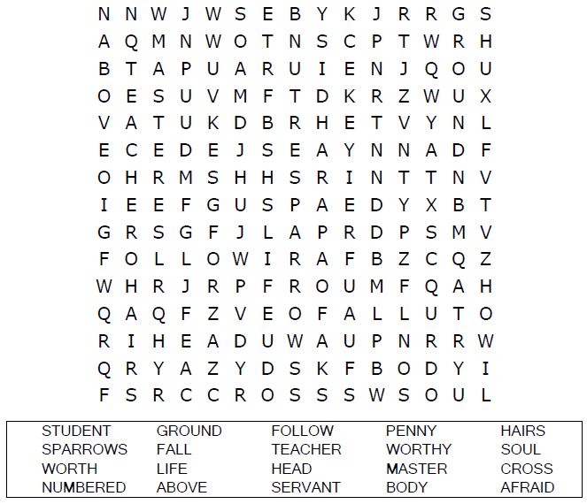

**Your Church’s Name  
Address  
City, State**

Coloring Page

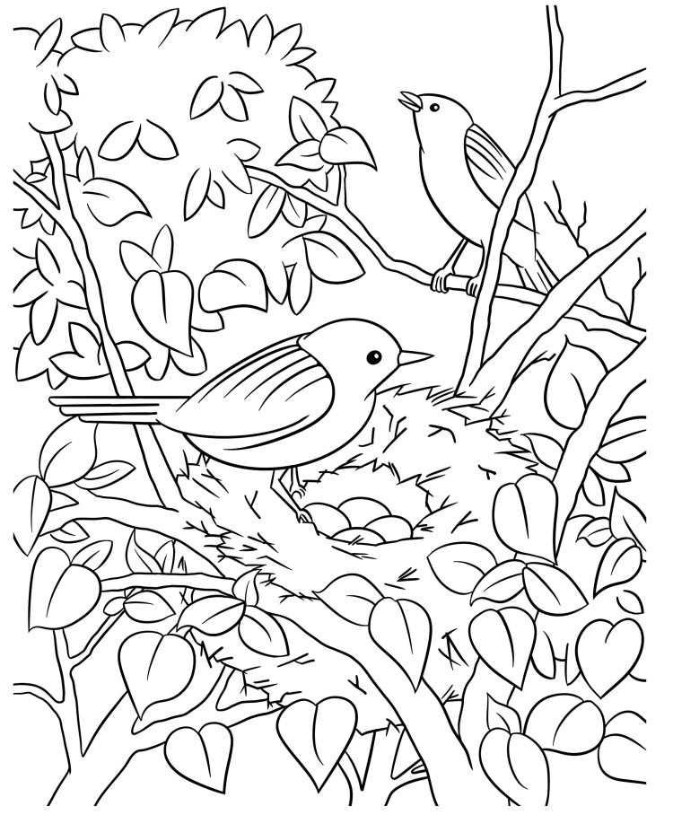  
  
"What is the price of two sparrows—one copper coin?   
But not a single sparrow can fall to the ground   
without your Father knowing it.

Multiple Choice Quiz

Choose the word that best matches the definition.  
Put the letter in the blank beside the definition.

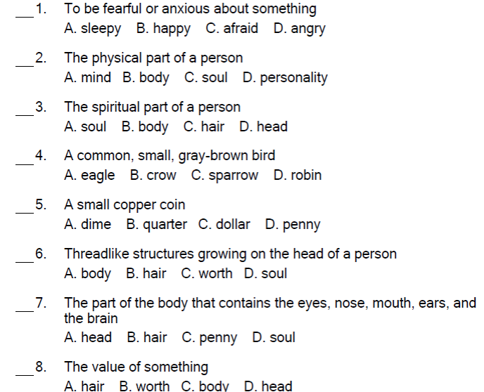



“So don’t be afraid; you are more valuable to God  
than a whole flock of sparrows.”   
Matthew 10:31