Crossword Puzzle

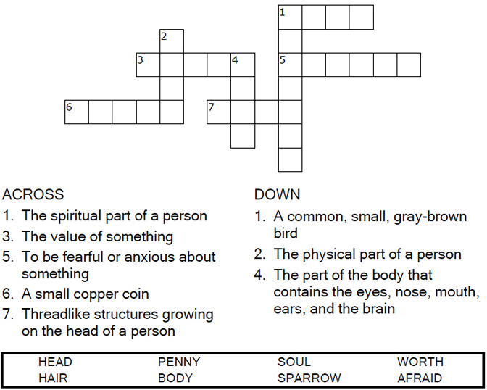

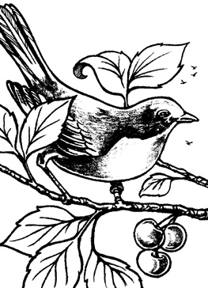

Copyright © Sermons4Kids, Inc.

May be reproduced for Ministry Use

**Children’s Worship Bulletin**



Mathew 10:24-39

Word Search Puzzle

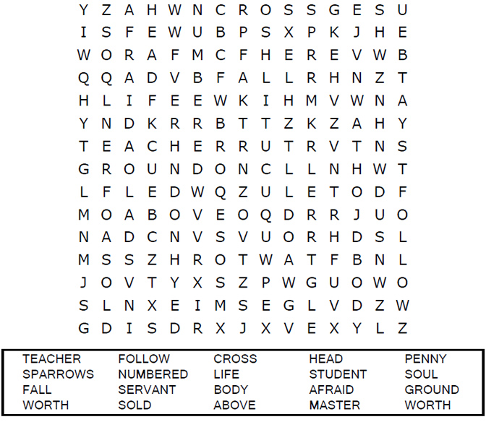  
  
**Your Church’s Name  
Address  
City, State**

Coloring Page

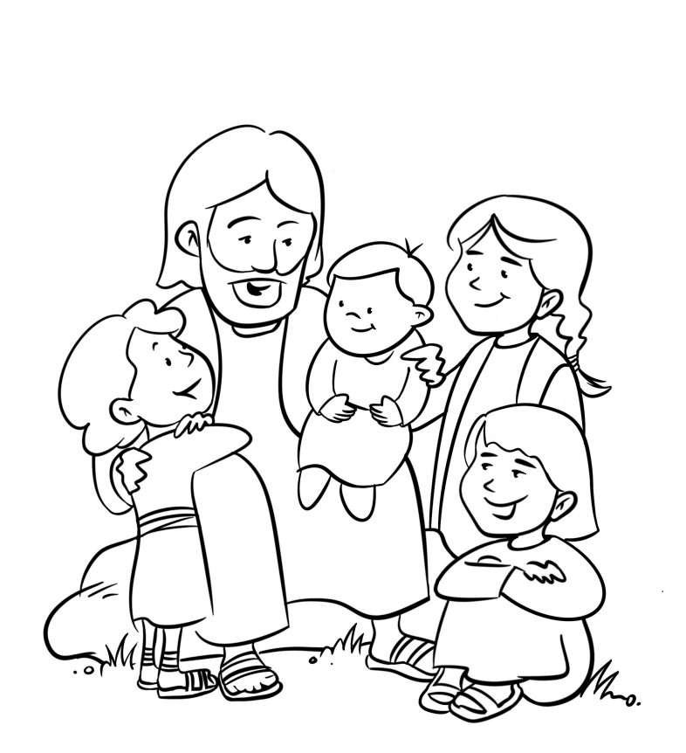  
  
Jesus and the Children

Multiple Choice Quiz

Each number represents a letter of the alphabet. Substitute  
the correct letter for the numbers to reveal the coded words.

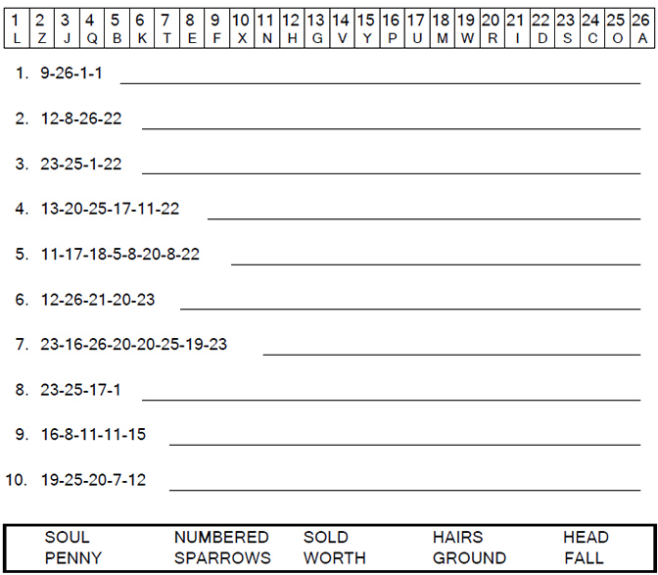



“So don’t be afraid; you are more valuable to God  
than a whole flock of sparrows.”   
Matthew 10:31