Crossword Puzzle

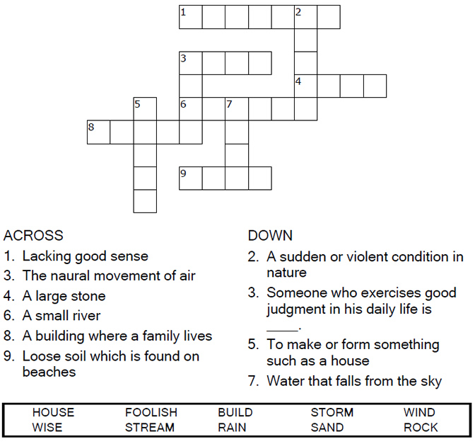



Copyright © Sermons4Kids, Inc.

May be reproduced for Ministry Use

**Children’s Worship Bulletin**



Matthew 7:24-27

Word Search Puzzle

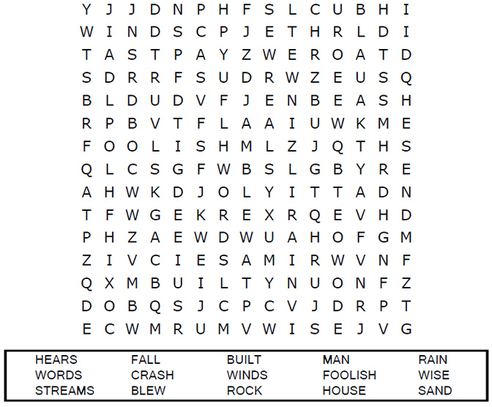

**Your Church Name Here  
Your City or Town**

Coloring Page

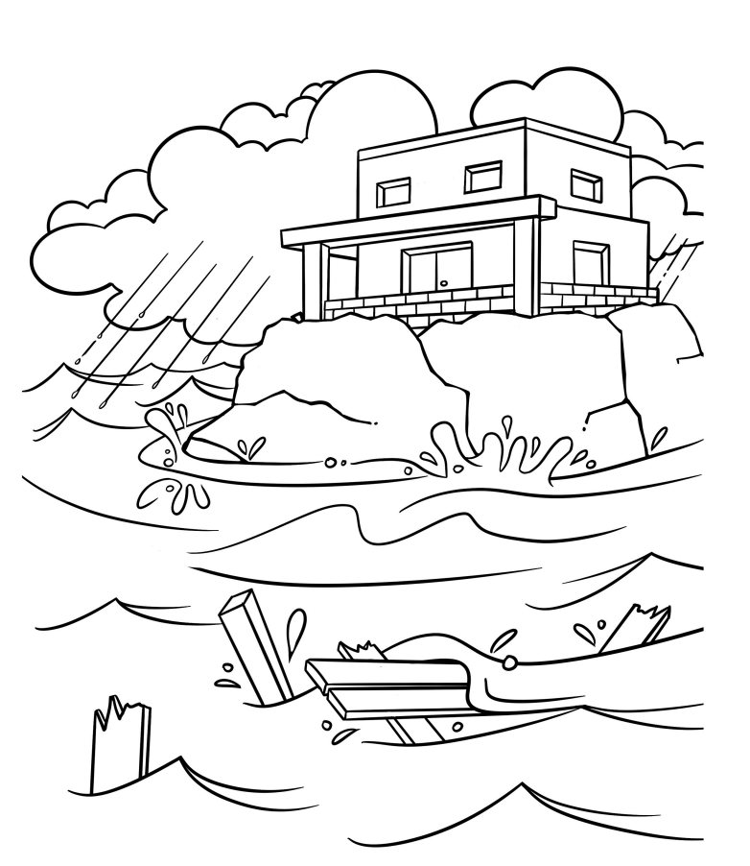

Copyright Calvary Chapel  
Used by permission

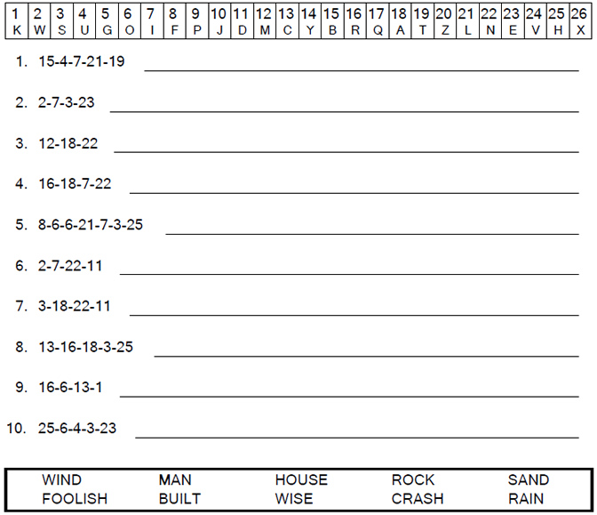  
  
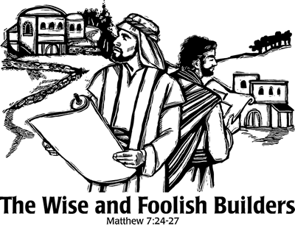

Decoder Puzzle