Crossword Puzzle

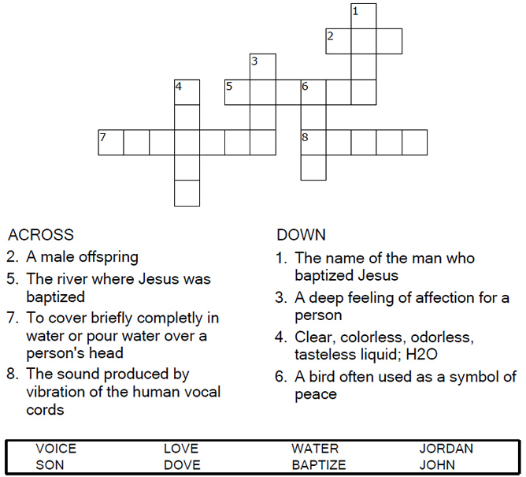



Copyright © Sermons4Kids, Inc.

May be reproduced for Ministry Use

Children’s Worship Bulletin



Luke 3:15-17, 21-22

Word Search

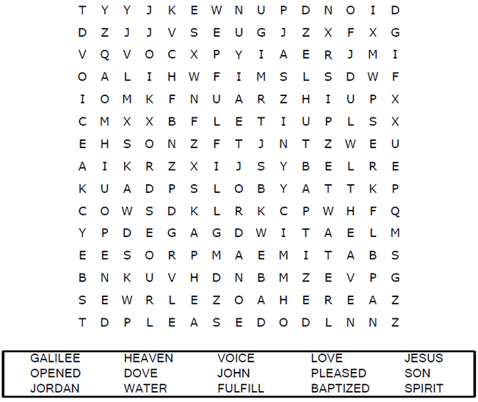

Your Church Name  
City or Town

Decoder Puzzle

Each number represents a letter of the alphabet. Substitute  
correct letter for the numbers to reveal the coded words.

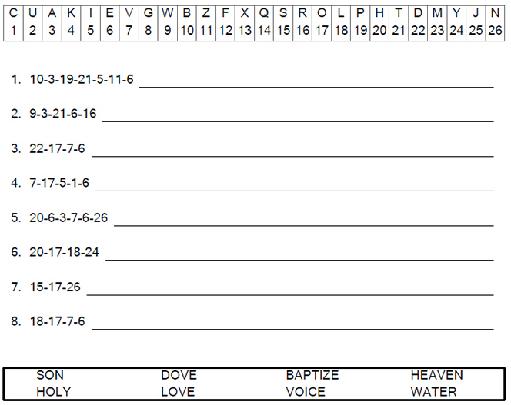

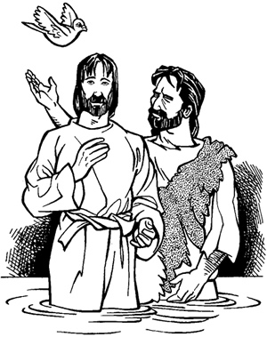

Coloring Page

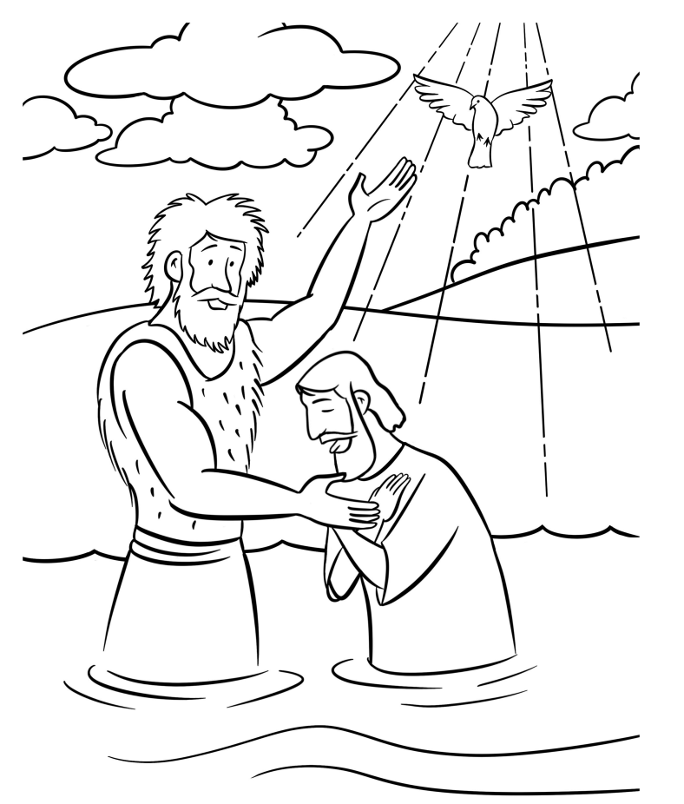

John Baptizes Jesus