Crossword Puzzle

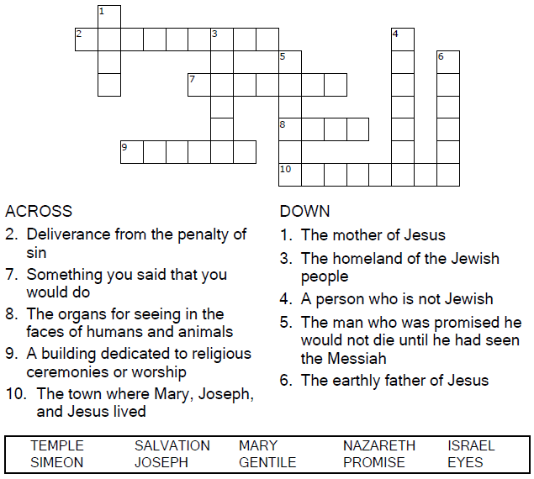

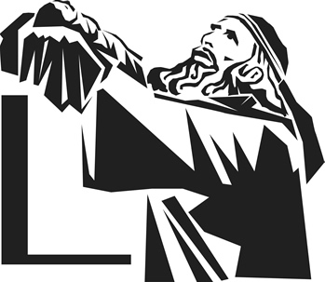  
  
Copyright © Sermons4Kids, Inc.

May be reproduced for Ministry Use

Children’s Worship Bulletin



Luke 2:22-40

Word Search

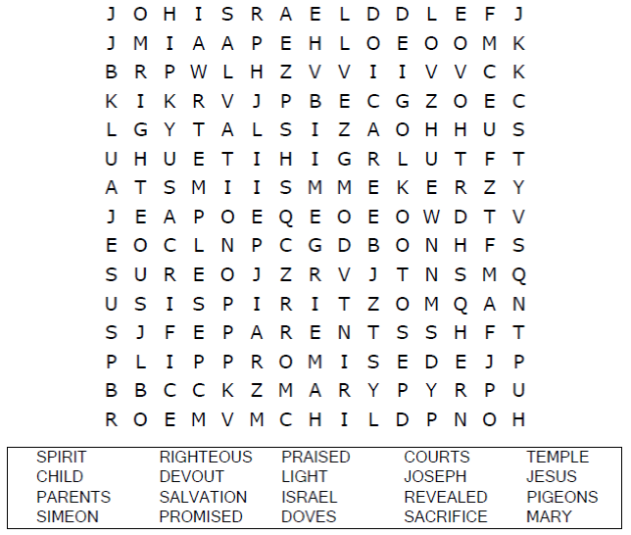

**Church Name**

**Address  
City**

Each number represents a letter of the alphabet. Substitute  
 the correct letter for the numbers to reveal the coded words.

Decoder Puzzle

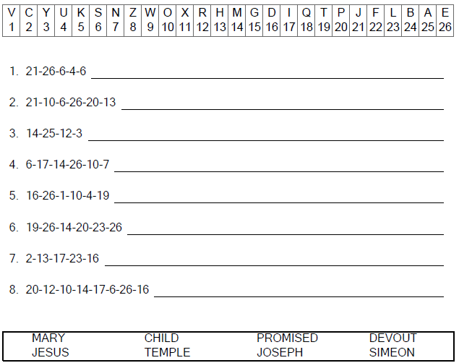  
  
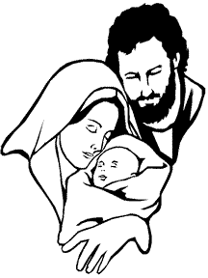

Color Me!

