Crossword Puzzle

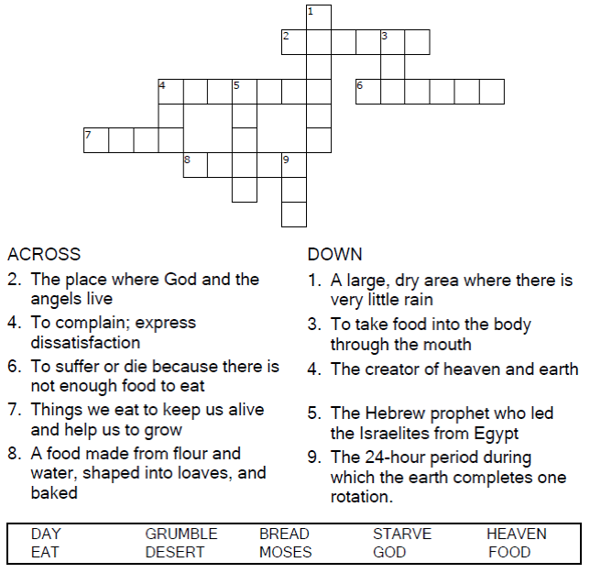

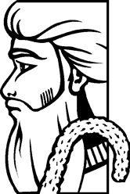

Copyright © Sermons4Kids, Inc.

May be reproduced for Ministry Use

**Children’s Worship Bulletin**



Exodus 16:2-15

Word Search Puzzle

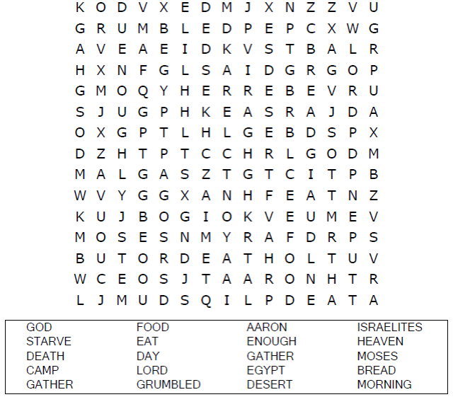  
  
**Church Name  
Address  
City**

Coloring Page

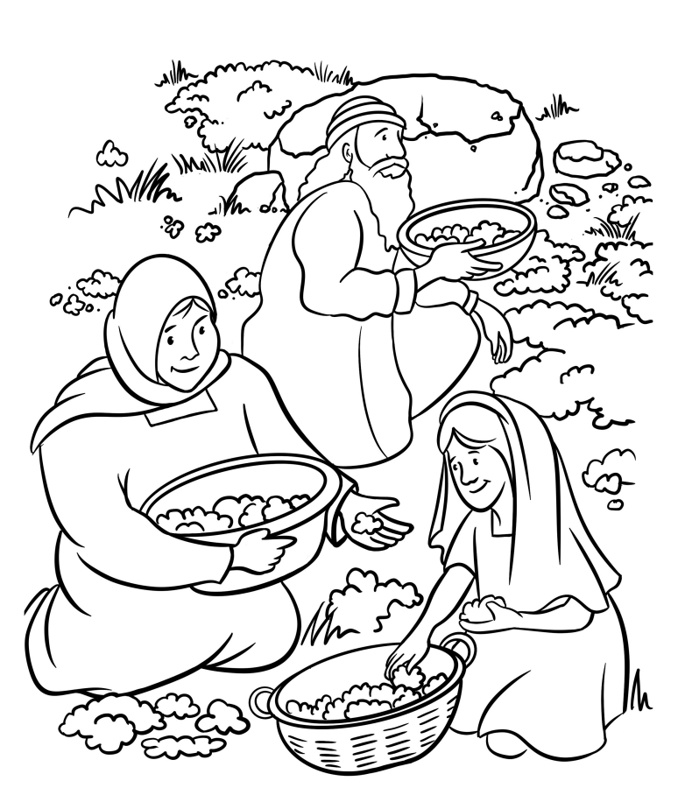

Moses said to them, “It is the bread that  
the LORD has given you to eat.”  
Exodus 16:15

Decoder Puzzle

Each number represents a letter of the alphabet.  
Substitute the correct letter for the numbers to  
reveal the coded words.

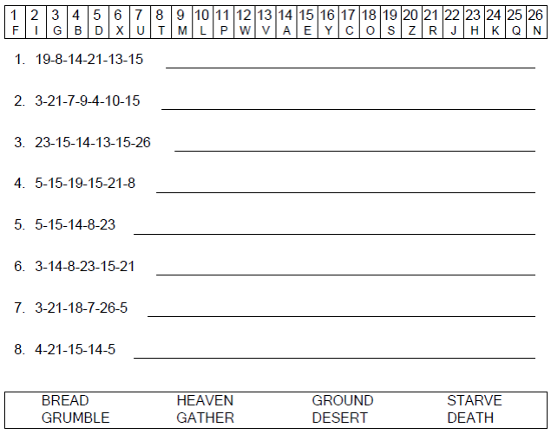

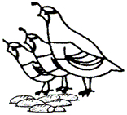

Manna & Quail