Crossword Puzzle

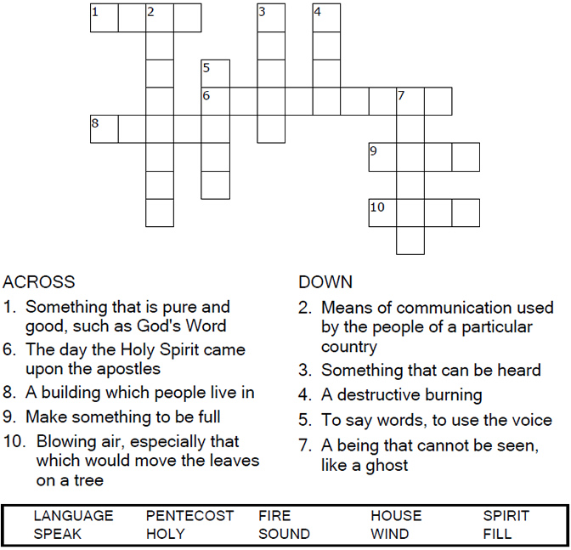



Copyright © Sermons4Kids, Inc.

May be reproduced for Ministry Use

Children’s Worship Bulletin



Acts 2:1-21

Word Search

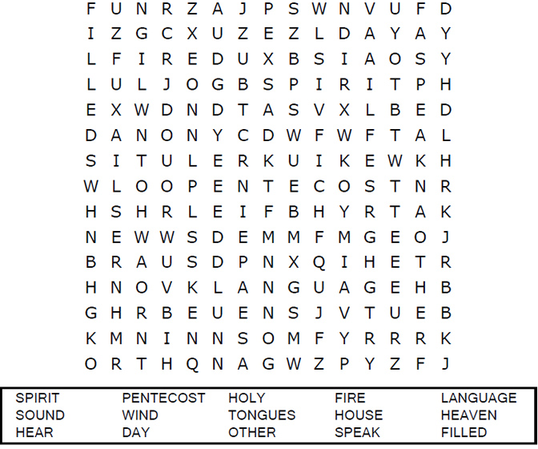

**Your Church Name Here**Anytown, USA

Word Jumble

Unscramble each word and then place the numbered letters  
in the numbered boxes at the bottom to reveal the answer.

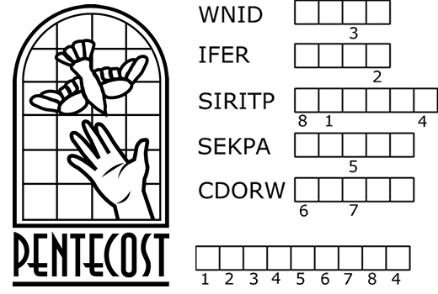

|  |
| --- |
| **PUZZLE CLUES** |
| 1. A sound like the blowing of a violent _______ came from heaven. |
| 2. They saw what seemed to be tongues of ______. |
| 3. All of them were filled with the Holy _______. |
| 4. They began to ______ in other tongues as the Spirit enabled them. |
| 5. Peter stood up and spoke to the ______ of people. |
| Answer: All of these events took place on the day of _____________. |
| Check your answers in Acts 2:1-14 (NIV) |

Color Me!

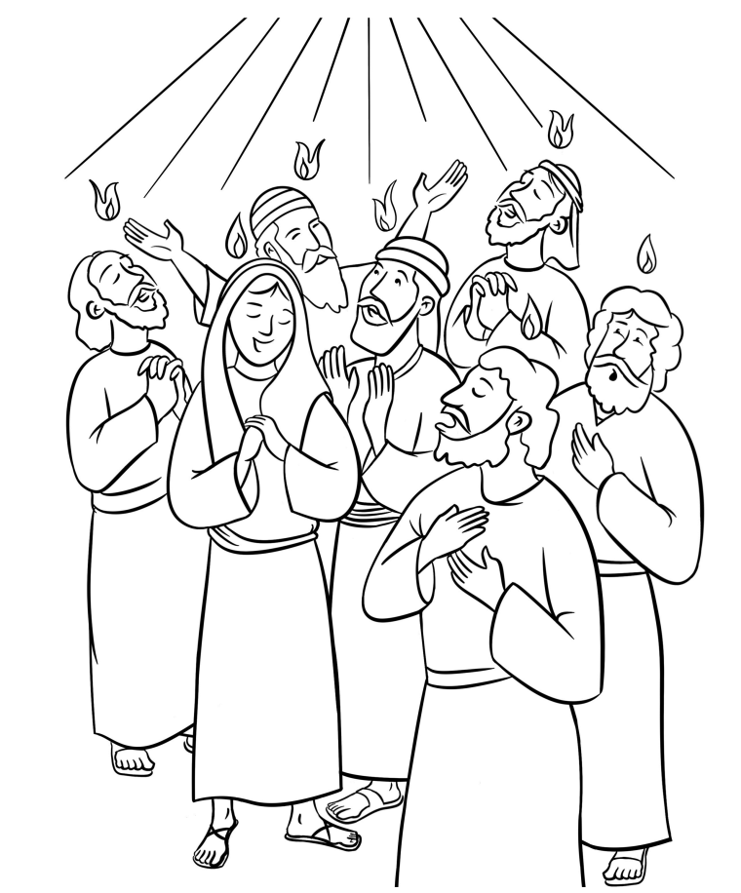

**The Day of Pentecost  
Acts 2**