Crossword Puzzle

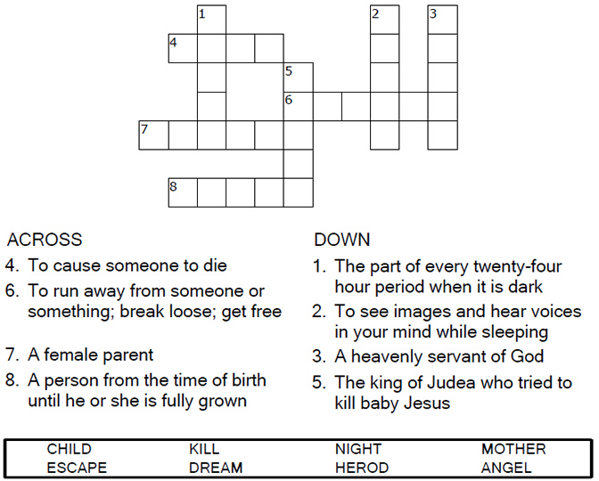

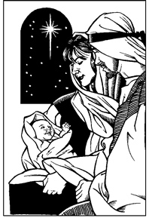

Copyright © Sermons4Kids, Inc.

May be reproduced for Ministry Use

Children’s Worship Bulletin



Matthew 2:13-23

Word Search

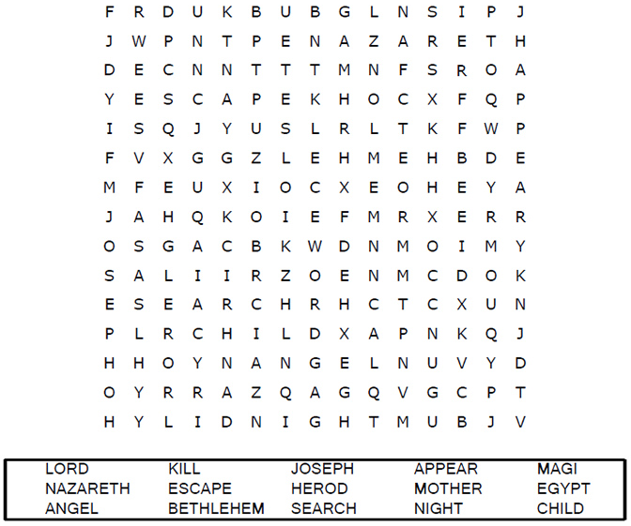

Your Church Name  
City or Town

Decoder Puzzle

Each number represents a letter of the alphabet. Substitute  
the correct letter for the numbers to reveal the coded words.

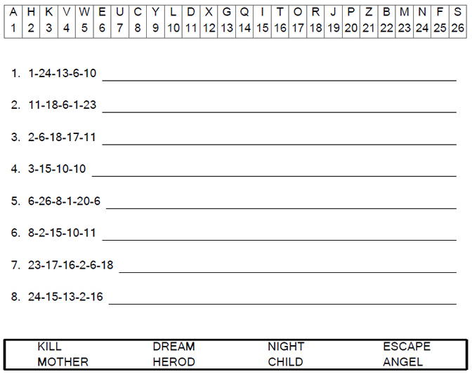

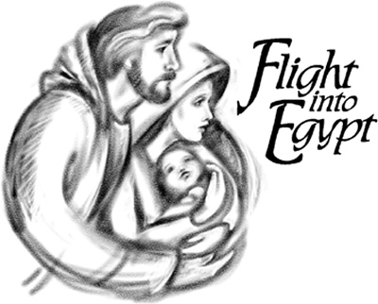

Coloring Page

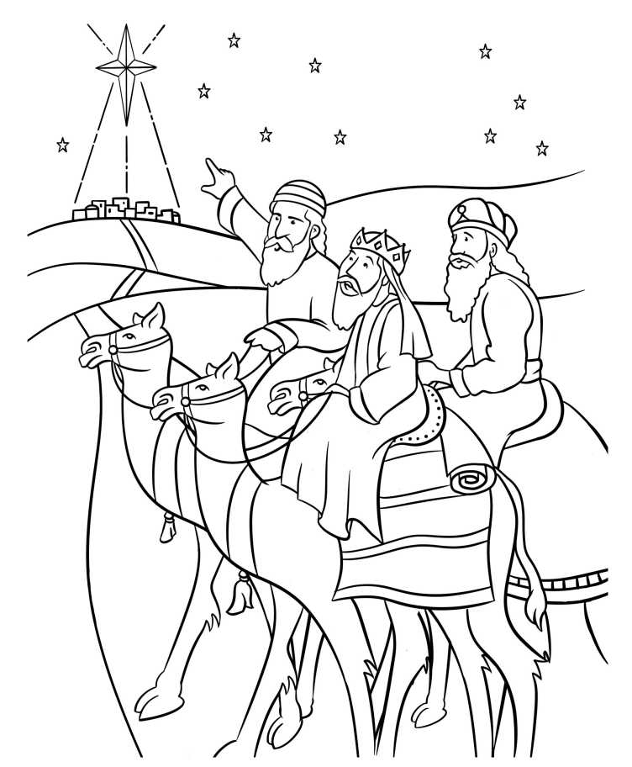

Wise Men Worship Jesus  
Matthew 2