Crossword Puzzle

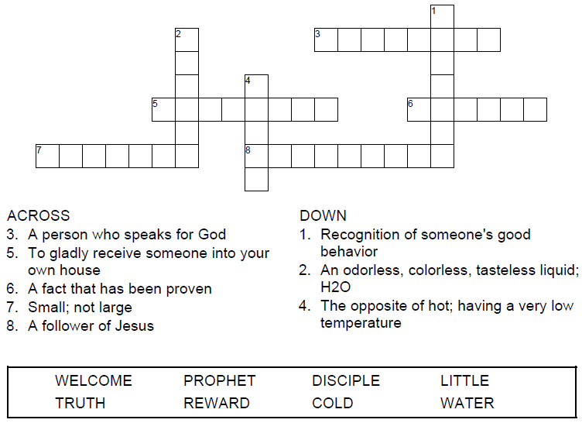



Copyright © Sermons4Kids, Inc.

May be reproduced for Ministry Use

**Children’s Worship Bulletin**



Matthew 10:40-42

Word Search Puzzle

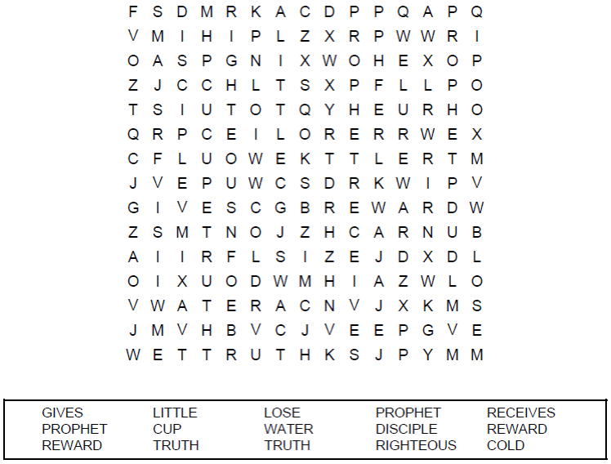

**Your Church Name  
Church Address  
City**

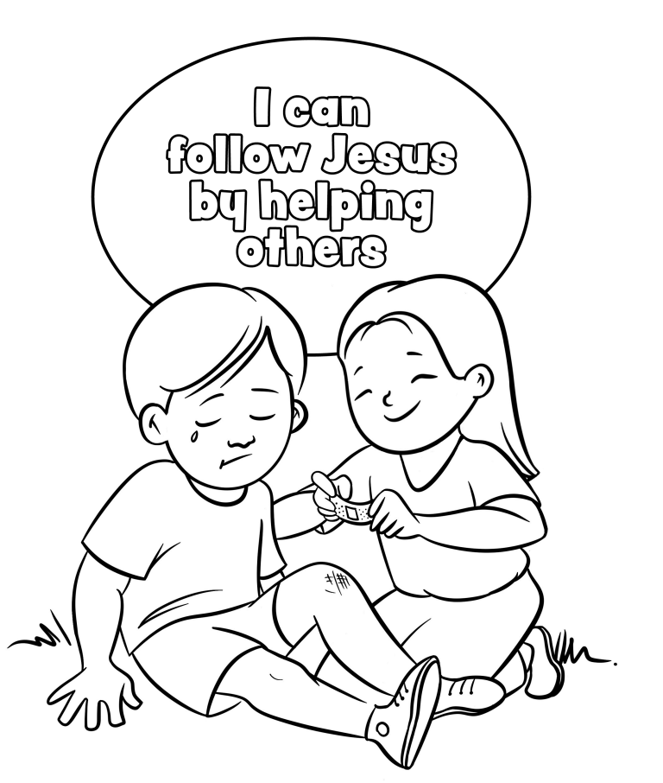

Coloring Page

“And if anyone gives even a cup of cold water to one of these little ones who is my disciple, truly I tell you, that person will certainly not lose their reward.”  
Matthew 10:42 (NIV)

Decoder Puzzle

Each number represents a letter of the alphabet. Substitute  
the correct letter for the numbers to reveal the coded words.

