Crossword Puzzle

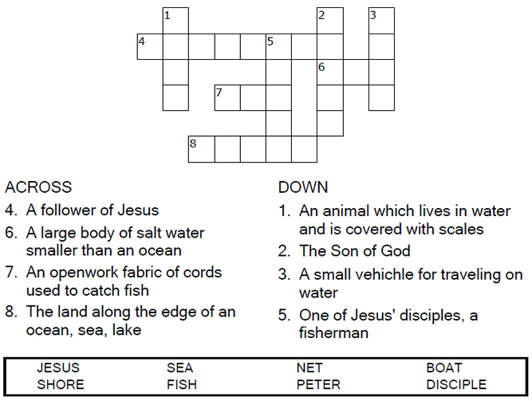

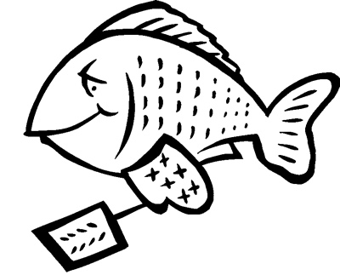

Copyright © Sermons4Kids, Inc.

May be reproduced for Ministry Use

Children’s Worship Bulletin



John 21:1-14

Word Search

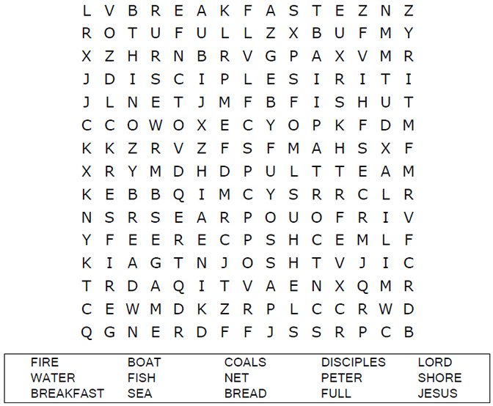

**Your Church Name Here**Anytown, USA

Dot to Dot

Connect the dots to complete the picture.

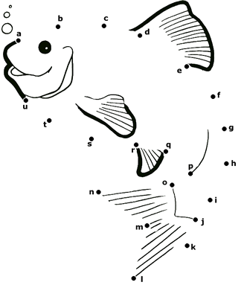

**He called out to them, "Friends, haven't you any fish?"**

**"No," they answered.**

**John 21:5-6 (NIV)**

Color Me!

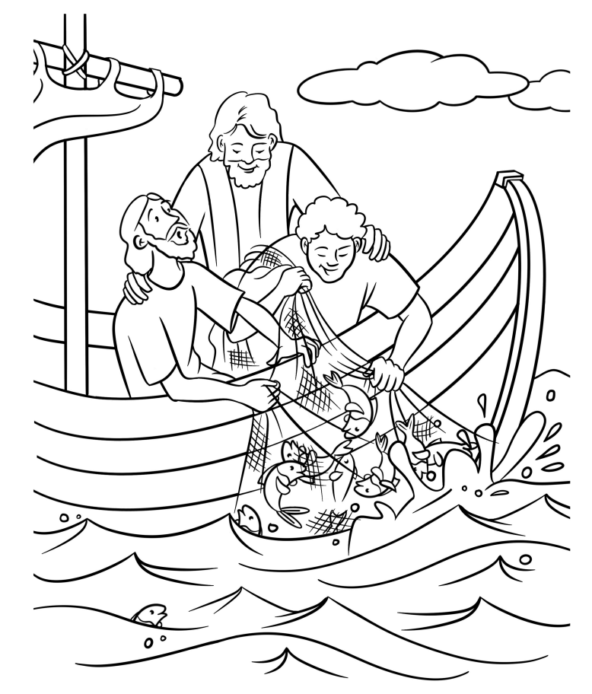

**Jesus Helps Catch Fish**