Crossword Puzzle

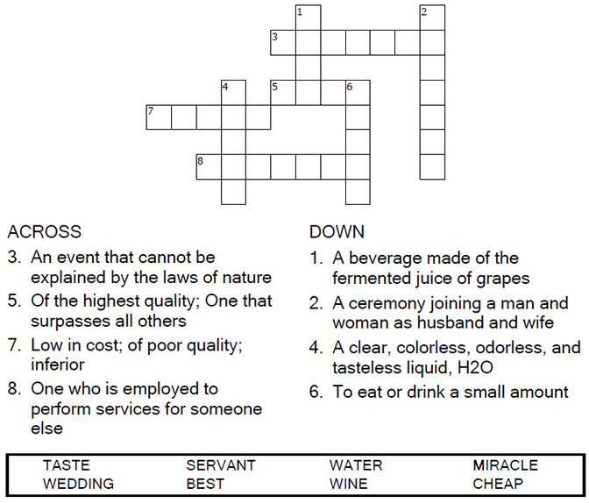

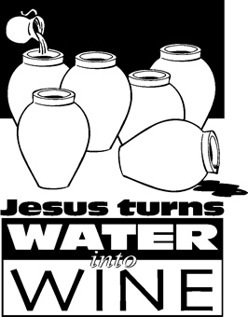

Copyright © Sermons4Kids, Inc.

May be reproduced for Ministry Use

Children’s Worship Bulletin



John 2:1-11

Word Search Puzzle

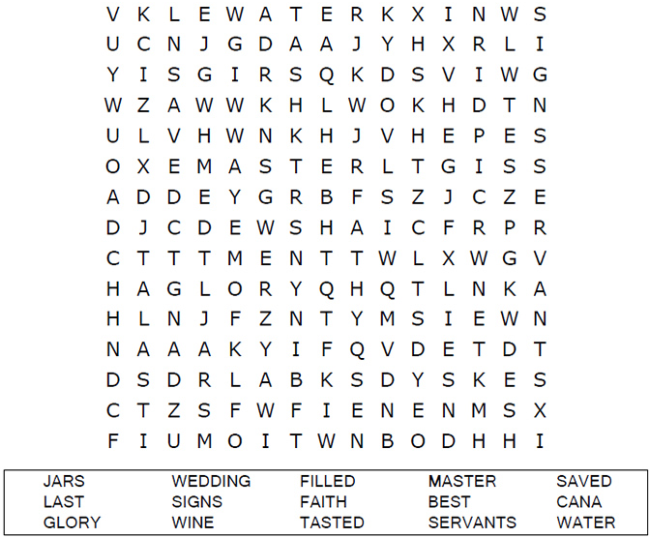

**Your Church Name Here**

Anytown, Anywhere

Multiple Choice Quiz

Choose the word that best matches the definition.

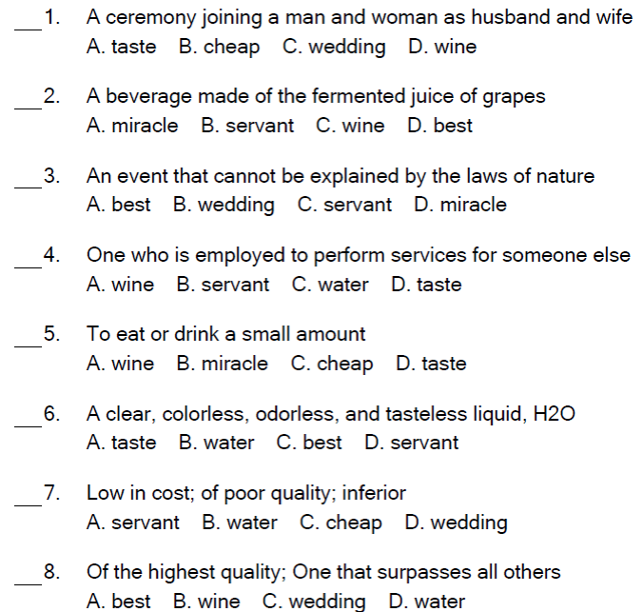

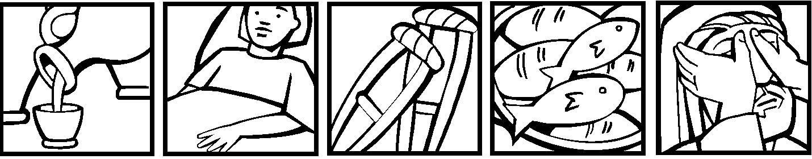

Coloring Page

